UNITED STATES
SECURITIES AND EXCHANGE COMMISSION
Washington, D.C. 20549

FORM 8-K

CURRENT REPORT

Pursuant to Section 13 OR 15(d) of the
Securities Exchange Act of 1934

Date of Report (Date of earliest event reported): April 28, 2022

META FINANCIAL GROUP, INC.
(Exact name of registrant as specified in its charter)

Delaware |  |  | 0-22140 |  |  | 42-1406262
(State or other jurisdiction of incorporation) |  |  | (Commission File Number) |  |  | (IRS Employer Identification No.)

5501 South Broadband Lane, Sioux Falls, South Dakota 57108
(Address of principal executive offices) (Zip Code)

Registrant’s telephone number, including area code: (877) 497-7497

Check the appropriate box below if the Form 8-K filing is intended to simultaneously satisfy the filing obligation of the registrant under any of the following provisions:
☐ |  |  | Written communications pursuant to Rule 425 under the Securities Act (17 CFR 230.425)
☐ |  |  | Soliciting material pursuant to Rule 14a-12 under the Exchange Act (17 CFR 240.14a-12)
☐ |  |  | Pre-commencement communications pursuant to Rule 14d-2(b) under the Exchange Act (17 CFR 240.14d- 2(b))
☐ |  |  | Pre-commencement communications pursuant to Rule 13e-4(c) under the Exchange Act (17 CFR 240.13e-4 (c))

Securities registered pursuant to Section 12(b) of the Act:
Title of each class |  |  | Trading Symbol(s) |  |  | Name of each exchange on which registered
Common Stock, $.01 par value |  |  | CASH |  |  | The NASDAQ Stock Market LLC

Indicate by check mark whether the registrant is an emerging growth company as defined in Rule 405 of the Securities Act of 1933 (§230.405 of this chapter) or Rule 12b-2 of the Securities Exchange Act of 1934 (§240.12b-2 of this chapter).
Emerging growth company ☐

If an emerging growth company, indicate by check mark if the registrant has elected not to use the extended transition period for complying with any new or revised financial accounting standards provided pursuant to Section 13(a) of the Exchange Act. ☐

Item 2.02 Results of Operations and Financial Condition.

On April 28, 2022, the Registrant issued a press release announcing its results of operations and financial condition as of and for the three and six months ended March 31, 2022. A copy of the press release is attached as Exhibit 99.1 to this report and is incorporated into this Item 2.02 by reference.

The information in this Item 2.02, including Exhibit 99.1, shall not be deemed to be “filed” for purposes of Section 18 of the Securities Exchange Act of 1934, as amended (the “Exchange Act”), or otherwise subject to the liabilities thereof, nor shall it be deemed to be incorporated by reference in any filing under the Exchange Act or under the Securities Act of 1933, as amended (the "Securities Act"), except to the extent specifically provided in any such filing.

Item 7.01 Regulation FD Disclosure.

Information is being furnished herein in Exhibit 99.2 with respect to the Investor Update slide presentation prepared for use with the press release. While most of the selected financial information furnished herein is derived from the Company’s consolidated financial statements and related notes prepared in accordance with generally accepted accounting principles ("GAAP") and management’s discussion and analysis of financial condition and results of operations included, or to be included, in the Company’s reports on Forms 10-K and 10-Q, this information includes selected financial and operational information through the second quarter of fiscal year 2022 and does not represent a complete set of financial statement and related notes prepared in conformity with GAAP. The Company’s annual financial statements are subject to independent audit. The Investor Update slide presentation is dated April 28, 2022 and the Company does not undertake to update the materials after that date.

The information in this Item 7.01, including Exhibit 99.2, shall not be deemed to be “filed” for purposes of Section 18 of the Exchange Act, or otherwise subject to the liabilities thereof, nor shall it be deemed to be incorporated by reference in any filing under the Exchange Act or under the Securities Act, except to the extent specifically provided in any such filing.

Item 9.01 Financial Statements and Exhibits.

(d) Exhibits
Exhibit Number |  |  |  |  |  | Description of Exhibit
99.1 |  |  |  |  |  | Press Release of Meta Financial Group, Inc., dated April 28, 2022 regarding the results of operations and financial condition.
99.2 |  |  |  |  |  | Investor Update slide presentation for the Second Quarter of Fiscal Year 2022, dated April 28, 2022, prepared for use with the Press Release.
104 |  |  |  |  |  | Cover Page Interactive Data File (embedded within the Inline XBRL document).

SIGNATURE
Pursuant to the requirements of the Securities Exchange Act of 1934, the Registrant has duly caused this report to be signed on its behalf by the undersigned hereunto duly authorized.

 |  |  |  |  |  | META FINANCIAL GROUP, INC.
Date: April 28, 2022 |  |  | By: |  |  | /s/ Glen W. Herrick
 |  |  |  |  |  | Glen W. Herrick
 |  |  |  |  |  | Executive Vice President and Chief Financial Officer

Exhibit 99.1

META FINANCIAL GROUP, INC.® ANNOUNCES RESULTS FOR 2022 FISCAL SECOND QUARTER
- Fiscal 2022 Second Quarter Net Income of $49.3 million, or $1.66 Per Diluted Share -
- Announces Name Change to Pathward Financial -
Sioux Falls, S.D., April 28, 2022 -- Meta Financial Group, Inc.® (Nasdaq: CASH) (“Meta” or the “Company”) reported net income of $49.3 million, or $1.66 per share, for the three months ended March 31, 2022, compared to net income of $59.1 million, or $1.84 per share, for the three months ended March 31, 2021. During the quarter the Company recognized $2.8 million of pre-tax expenses related to rebranding efforts. Excluding the impact of the rebranding expenses, net of tax, the Company's adjusted net income for the quarter totaled $51.4 million, or $1.73 per share. See non-GAAP reconciliation table below.
CEO Brett Pharr said, "Although our tax services and renewable energy investment tax credit products produced results below our expectations, the balance of our businesses performed well. Our commercial finance portfolio saw continued healthy loan growth from satisfying small and medium sized businesses’ robust demand for credit, and our Banking as a Service pipeline of opportunities remains strong.”
“Last month, we announced our new corporate name, Pathward Financial. Pathward signifies our Company’s purpose to power financial inclusion for all by creating a path forward for individuals and businesses to meet their financial goals. The name reflects our dedication to removing the barriers that prevent millions of Americans from accessing the financial system and will serve as a constant reminder of our mission to meet the needs of the unbanked, underbanked, and underserved to help them achieve economic mobility,” Pharr added.

Tax Season
For the 2022 tax season, MetaBank originated $1.83 billion in refund advance loans compared to $1.79 billion during the 2021 tax season. The Company expects taxpayer advance volumes to return to more normalized levels in the 2023 tax season, absent further stimulus or additional changes to tax credit payments.
During the second quarter of fiscal 2022, total tax services product revenue was $68.3 million, an increase of 2% compared to the second quarter of fiscal 2021. Both total tax services product fee income and total tax services product expense were approximately flat compared to the prior year period. Net interest income on tax services loans increased $1.5 million during the second quarter of fiscal 2022 compared to the second quarter last year.
Total tax services product income, net of losses and direct product expenses, increased 6% to $34.4 million from $32.6 million, when comparing the first six months of fiscal 2022 to the same period of the prior fiscal year.
Business Development Highlights for the 2022 Fiscal Second Quarter
•On March 29, 2022, the Company announced it is changing its name to Pathward Financial, Inc.™, and its bank subsidiary, MetaBank®, N.A., will be changing its name to Pathward™, N.A. Certain changes will be made immediately, with a full transition to Pathward expected by the end of this calendar year, including the launch of a new brand identity and website. The Company will continue to serve its customers under existing brand names during the transition. The Company recognized $2.8 million of pre-tax expenses related to rebranding efforts during the second quarter of fiscal 2022. The Company continues to estimate total rebranding expenses will range between $15 million to $20 million.
•On April 27, 2022 Meta published its second annual ESG report. In addition to detailing the Company's community impact program and its diversity, equity, and inclusion initiatives, it contains enhanced quantitative reporting, which will be used to measure progress.

1

Financial Highlights for the 2022 Fiscal Second Quarter
•Total revenue for the second quarter was $193.6 million, an increase of $6.2 million, or 3%, compared to the same quarter in fiscal 2021, primarily driven by an increase in interest income, partially offset by a reduction in noninterest income.
•Net interest income for the second quarter was $83.8 million, an increase of $10.0 million compared to $73.9 million in the second quarter last year.
•Net interest margin ("NIM") increased to 4.80% for the second quarter from 3.07% during the same period of last year. The prior year period was impacted by excess cash associated with the Company's participation in the U.S. Treasury Department's Economic Impact Program.
•Total gross loans and leases at March 31, 2022 increased $78.1 million, to $3.73 billion, or 2%, compared to March 31, 2021 and increased $43.5 million, or 1%, when compared to December 31, 2021. The increase compared to the prior year quarter was driven by growth across our loan portfolios, partially offset by the sale of all remaining community banking loans during the fiscal 2022 first quarter.
•The Company originated $1.3 million in aggregate principal of renewable energy loan financing for the second quarter of fiscal 2022, resulting in $0.3 million in total net investment tax credits.
•The Company repurchased 736,198 shares of its common stock at an average price of $57.01, in the second fiscal quarter and has 4,868,177 shares available for repurchase under the common stock share repurchase program announced during the fourth quarter of fiscal year 2021.
•On March 24, 2022, the Company's Board of Directors approved the redemption at par of $75.0 million of the 5.75% fixed to floating rate note due August 15, 2026. The redemption date is set for May 15, 2022.

Net Interest Income
Net interest income for the second quarter of fiscal 2022 was $83.8 million, an increase of 13% from the same quarter in fiscal 2021. The increase was mainly attributable to an improved earning asset mix, together with increased loan balances.
The second quarter average outstanding balance of loans and leases increased $124.1 million compared to the same quarter of the prior year, primarily due to increases in our core loan and lease portfolios, partially offset by the sale of the remaining community bank portfolio. The Company’s average interest-earning assets for the second quarter decreased by $2.69 billion to $7.08 billion compared with the same quarter in fiscal 2021, primarily due to a reduction in cash balances as a result of high cash levels during the prior year period related to the Company's participation in government stimulus programs. The decrease in interest-earnings assets was partially offset by growth in total investments and total loans and leases.
Fiscal 2022 second quarter NIM increased to 4.80% from 3.07% in the second quarter of last year. The overall reported tax-equivalent yield (“TEY”) on average earning asset yields increased 174 basis points to 4.89% compared to the prior year quarter, primarily driven by a decrease in lower-yielding cash balances. Growth in loan and lease and investment securities balances also contributed to the year-over-year TEY increase. The yield on the loan and lease portfolio was 7.22% compared to 6.74% for the comparable period last year and the TEY on the securities portfolio was 1.83% compared to 1.78% over that same period.
The Company's cost of funds for all deposits and borrowings averaged 0.08% during the fiscal 2022 second quarter, the same as the prior year quarter. The Company's overall cost of deposits was 0.01% in the fiscal second quarter of 2022, compared to 0.02% in the same quarter last year.

Noninterest Income
Fiscal 2022 second quarter noninterest income decreased to $109.8 million, compared to $113.5 million for the same period of the prior year. The decrease was driven by a reduction in payments fee income of $3.6 million and a net loss on our MoneyLion investment of $1.3 million, partially offset by an increase in rental income of $1.5 million.
2

During the second quarter of fiscal year 2022, the Company sold the entirety of its equity investment in MoneyLion, recognizing a net loss of $1.3 million during the current period. Following the completion of MoneyLion's de-SPAC process and listing on the New York Stock Exchange on September 22, 2021, the Company recognized a cumulative loss of approximately $0.4 million on the investment dating back to the fourth quarter of fiscal year 2021. The Company continues to be a strategic BaaS provider to MoneyLion.
Noninterest Expense
Noninterest expense increased 7% to $103.2 million for the fiscal 2022 second quarter, from $96.0 million for the same quarter last year. The increase in expense was primarily driven by an increase in consulting expense, software expense, operating lease equipment depreciation and compensation expense. Compensation expense for the second quarter of fiscal 2022 includes $0.9 million of separation-related expenses. When comparing the fiscal 2022 second quarter to the first quarter of 2022, noninterest expense increased by $20.7 million.
Of the $2.8 million in rebranding expenses the Company incurred during the quarter, $2.0 million is recognized in other expense and $0.8 million is related to legal and consulting expense.
Income Tax Expense
The Company recorded income tax expense of $8.0 million, representing an effective tax rate of 13.8%, for the fiscal 2022 second quarter, compared to $1.1 million, representing an effective tax rate of 1.9%, for the second quarter last year. The current quarter increase in income tax expense was primarily due to a reduction in renewable energy investment tax credit lending volume compared to the prior year period.
The Company originated $1.3 million in solar leases during the fiscal 2022 second quarter, compared to $20.0 million in last year's second quarter. Investment tax credits related to solar leases are recognized ratably based on income throughout each fiscal year. For the six months ended March 31, 2022, the Company originated $22.5 million in solar leases, compared to $58.5 million for the comparable prior year period. The timing and impact of future solar tax credits are expected to vary from period to period, and Meta intends to undertake only those tax credit opportunities that meet the Company's underwriting and return criteria.
3

Investments, Loans and Leases
(dollars in thousands) |  |  | March 31, 2022 |  |  |  |  |  | December 31, 2021 |  |  |  |  |  | September 30, 2021 |  |  |  |  |  | June 30, 2021 |  |  |  |  |  | March 31, 2021
Total investments |  |  | $ | 2,090,765 |  |  |  |  | $ | 1,833,733 |  |  |  |  | $ | 1,921,568 |  |  |  |  | $ | 1,981,852 |  |  |  |  | $ | 1,552,892
Loans held for sale
Consumer credit products |  |  | 23,670 |  |  |  |  |  | 20,728 |  |  |  |  |  | 23,111 |  |  |  |  |  | 12,582 |  |  |  |  |  | 6,233
SBA/USDA |  |  | 7,740 |  |  |  |  |  | 15,454 |  |  |  |  |  | 33,083 |  |  |  |  |  | 57,208 |  |  |  |  |  | 61,402
Community bank |  |  | — |  |  |  |  |  | — |  |  |  |  |  | — |  |  |  |  |  | 18,115 |  |  |  |  |  | —
Total loans held for sale |  |  | 31,410 |  |  |  |  |  | 36,182 |  |  |  |  |  | 56,194 |  |  |  |  |  | 87,905 |  |  |  |  |  | 67,635
Term lending |  |  | 1,111,076 |  |  |  |  |  | 1,038,378 |  |  |  |  |  | 961,019 |  |  |  |  |  | 920,279 |  |  |  |  |  | 891,414
Asset based lending |  |  | 382,355 |  |  |  |  |  | 337,236 |  |  |  |  |  | 300,225 |  |  |  |  |  | 263,237 |  |  |  |  |  | 248,735
Factoring |  |  | 394,865 |  |  |  |  |  | 402,972 |  |  |  |  |  | 363,670 |  |  |  |  |  | 320,629 |  |  |  |  |  | 277,612
Lease financing |  |  | 235,397 |  |  |  |  |  | 245,315 |  |  |  |  |  | 266,050 |  |  |  |  |  | 282,940 |  |  |  |  |  | 308,169
Insurance premium finance |  |  | 403,681 |  |  |  |  |  | 385,473 |  |  |  |  |  | 428,867 |  |  |  |  |  | 417,652 |  |  |  |  |  | 344,841
SBA/USDA |  |  | 214,195 |  |  |  |  |  | 209,521 |  |  |  |  |  | 247,756 |  |  |  |  |  | 263,709 |  |  |  |  |  | 331,917
Other commercial finance |  |  | 173,260 |  |  |  |  |  | 178,853 |  |  |  |  |  | 157,908 |  |  |  |  |  | 118,081 |  |  |  |  |  | 103,234
Commercial finance |  |  | 2,914,829 |  |  |  |  |  | 2,797,748 |  |  |  |  |  | 2,725,495 |  |  |  |  |  | 2,586,527 |  |  |  |  |  | 2,505,922
Consumer credit products |  |  | 171,847 |  |  |  |  |  | 173,343 |  |  |  |  |  | 129,251 |  |  |  |  |  | 105,440 |  |  |  |  |  | 104,842
Other consumer finance |  |  | 111,922 |  |  |  |  |  | 144,412 |  |  |  |  |  | 123,606 |  |  |  |  |  | 122,316 |  |  |  |  |  | 130,822
Consumer finance |  |  | 283,769 |  |  |  |  |  | 317,755 |  |  |  |  |  | 252,857 |  |  |  |  |  | 227,756 |  |  |  |  |  | 235,664
Tax services |  |  | 85,999 |  |  |  |  |  | 100,272 |  |  |  |  |  | 10,405 |  |  |  |  |  | 41,268 |  |  |  |  |  | 225,921
Warehouse finance |  |  | 441,496 |  |  |  |  |  | 466,831 |  |  |  |  |  | 419,926 |  |  |  |  |  | 335,704 |  |  |  |  |  | 332,456
Community banking |  |  | — |  |  |  |  |  | — |  |  |  |  |  | 199,132 |  |  |  |  |  | 303,984 |  |  |  |  |  | 348,065
Total loans and leases |  |  | 3,726,093 |  |  |  |  |  | 3,682,606 |  |  |  |  |  | 3,607,815 |  |  |  |  |  | 3,495,239 |  |  |  |  |  | 3,648,028
Net deferred loan origination costs |  |  | 4,097 |  |  |  |  |  | 1,655 |  |  |  |  |  | 1,748 |  |  |  |  |  | 1,431 |  |  |  |  |  | 9,503
Total gross loans and leases |  |  | 3,730,190 |  |  |  |  |  | 3,684,261 |  |  |  |  |  | 3,609,563 |  |  |  |  |  | 3,496,670 |  |  |  |  |  | 3,657,531
Allowance for credit losses |  |  | (88,552) |  |  |  |  |  | (67,623) |  |  |  |  |  | (68,281) |  |  |  |  |  | (91,208) |  |  |  |  |  | (98,892)
Total loans and leases, net |  |  | $ | 3,641,638 |  |  |  |  | $ | 3,616,638 |  |  |  |  | $ | 3,541,282 |  |  |  |  | $ | 3,405,462 |  |  |  |  | $ | 3,558,639

The Company's investment security balances at March 31, 2022 totaled $2.09 billion, as compared to $1.83 billion at December 31, 2021 and $1.55 billion at March 31, 2021.
Total gross loans and leases totaled $3.73 billion at March 31, 2022, as compared to $3.68 billion at December 31, 2021 and $3.66 billion at March 31, 2021. The primary driver for the increase on a linked quarter basis was commercial finance loans. The year-over-year increase was primarily driven by increases within commercial finance, warehouse finance, and consumer finance, partially offset by a reduction in tax services loans and the sale of all remaining community bank loans.
Commercial finance loans, which comprised 78% of the Company's gross loan and lease portfolio, totaled $2.91 billion at March 31, 2022, reflecting growth of $117.1 million, or 4%, from December 31, 2021 and $408.9 million, or 16%, from March 31, 2021.
As of March 31, 2022, the Company had 164 loans outstanding with total loan balances of $43.0 million originated as part of the Paycheck Protection Program ("PPP"), compared with 275 loans outstanding with total loan balances of $63.8 million for the quarter ended December 31, 2021. In total, approximately 85% of the PPP loan balances were forgiven through March 31, 2022.
Asset Quality
The Company’s allowance for credit losses ("ACL") totaled $88.6 million at March 31, 2022, an increase compared to $67.6 million at December 31, 2021 and a decrease from $98.9 million at March 31, 2021. The increase in the ACL at March 31, 2022, when compared to December 31, 2021, was primarily due to the seasonal tax services loan portfolio, which increased $29.2 million during the fiscal 2022 second quarter.
4

The $10.3 million year-over-year decrease in the ACL was primarily driven by a $14.0 million decrease attributable to the disposition of the community banking portfolio, along with a $2.1 million decrease in the consumer finance portfolio. These decreases were partially offset by a $4.0 million increase within the commercial finance portfolio and a $1.6 million increase within the tax services portfolio.
The following table presents the Company's ACL as a percentage of its total loans and leases.

 |  |  | As of the Period Ended
(Unaudited) |  |  | March 31, 2022 |  |  | December 31, 2021 |  |  | September 30, 2021 |  |  | June 30, 2021 |  |  | March 31, 2021
Commercial finance |  |  | 1.66 |  | % | 2.04 |  | % | 1.77 |  | % | 1.73 |  | % | 1.77 |  | %
Consumer finance |  |  | 3.18 |  | % | 2.70 |  | % | 2.91 |  | % | 3.80 |  | % | 4.70 |  | %
Tax services |  |  | 35.76 |  | % | 1.60 |  | % | 0.02 |  | % | 58.99 |  | % | 12.90 |  | %
Warehouse finance |  |  | 0.10 |  | % | 0.10 |  | % | 0.10 |  | % | 0.10 |  | % | 0.10 |  | %
Community banking |  |  | — |  | % | — |  | % | 6.16 |  | % | 4.36 |  | % | 4.03 |  | %
Total loans and leases |  |  | 2.38 |  | % | 1.84 |  | % | 1.89 |  | % | 2.61 |  | % | 2.71 |  | %
Total loans and leases excluding tax services |  |  | 1.59 |  | % | 1.84 |  | % | 1.90 |  | % | 1.94 |  | % | 2.04 |  | %

The Company's ACL as a percentage of total loans and leases increased to 2.38% at March 31, 2022 from 1.84% at December 31, 2021. The increase in the total loans and leases coverage ratio was primarily driven by the seasonal tax services loan portfolio. The coverage ratio for the commercial finance portfolio decreased compared to the December 31, 2021 quarter due to reduction of specific reserves on two individually evaluated loan relationships. The Company expects to continue to diligently monitor the ACL and adjust as necessary in future periods to maintain an appropriate and supportable level.
Activity in the allowance for credit losses for the periods presented was as follows.

(Unaudited) |  |  | Three Months Ended |  |  |  |  |  |  |  |  |  |  |  | Six Months Ended
(Dollars in thousands) |  |  | March 31, 2022 |  |  | December 31, 2021 |  |  | March 31, 2021 |  |  |  |  |  | March 31, 2022 |  |  | March 31, 2021
Beginning balance |  |  | $ | 67,623 |  | $ | 68,281 |  | $ | 72,389 |  |  |  |  | $ | 68,281 |  | $ | 56,188
Adoption of CECL accounting standard |  |  | — |  |  | — |  |  | — |  |  |  |  |  | — |  |  | 12,773
Provision (reversal of) - tax services loans |  |  | 28,972 |  |  | (714) |  |  | 27,680 |  |  |  |  |  | 28,259 |  |  | 28,134
Provision - all other loans and leases |  |  | 3,183 |  |  | 1,184 |  |  | 2,519 |  |  |  |  |  | 4,368 |  |  | 8,329
Charge-offs - tax services loans |  |  | — |  |  | (254) |  |  | — |  |  |  |  |  | (254) |  |  | —
Charge-offs - all other loans and leases |  |  | (12,415) |  |  | (4,605) |  |  | (4,248) |  |  |  |  |  | (17,021) |  |  | (9,923)
Recoveries - tax services loans |  |  | 184 |  |  | 2,567 |  |  | 54 |  |  |  |  |  | 2,750 |  |  | 1,010
Recoveries - all other loans and leases |  |  | 1,005 |  |  | 1,164 |  |  | 498 |  |  |  |  |  | 2,169 |  |  | 2,381
Ending balance |  |  | $ | 88,552 |  | $ | 67,623 |  | $ | 98,892 |  |  |  |  | $ | 88,552 |  | $ | 98,892
The Company recognized a provision for credit losses of $32.3 million for the quarter ended March 31, 2022, compared to $30.3 million for the comparable period in the prior fiscal year. Net charge-offs were $11.2 million for the quarter ended March 31, 2022, compared to $3.7 million for the quarter ended March 31, 2021. Net charge-offs attributable to the commercial finance portfolio for the quarter were $10.7 million and net charge-offs attributable to the consumer finance portfolio were $0.7 million.

5

The Company's past due loans and leases were as follows for the periods presented.

As of March 31, 2022 |  |  | Accruing and Nonaccruing Loans and Leases |  |  |  |  |  |  |  |  |  |  |  |  |  |  |  |  |  |  |  |  |  |  |  |  |  |  |  |  |  |  |  |  |  |  |  | Nonperforming Loans and Leases
(Dollars in thousands) |  |  | 30-59 Days Past Due |  |  |  |  |  | 60-89 Days Past Due |  |  |  |  |  | > 89 Days Past Due |  |  |  |  |  | Total Past Due |  |  |  |  |  | Current |  |  |  |  |  | Total Loans and Leases Receivable |  |  |  |  |  | > 89 Days Past Due and Accruing |  |  |  |  |  | Nonaccrual Balance |  |  |  |  |  | Total
Loans held for sale |  |  | $ | — |  |  |  |  | $ | — |  |  |  |  | $ | — |  |  |  |  | $ | — |  |  |  |  | $ | 31,410 |  |  |  |  | $ | 31,410 |  |  |  |  | $ | — |  |  |  |  | $ | — |  |  |  |  | $ | —
Commercial finance |  |  | 24,631 |  |  |  |  |  | 2,574 |  |  |  |  |  | 11,994 |  |  |  |  |  | 39,199 |  |  |  |  |  | 2,875,630 |  |  |  |  |  | 2,914,829 |  |  |  |  |  | 5,701 |  |  |  |  |  | 25,327 |  |  |  |  |  | 31,028
Consumer finance |  |  | 5,829 |  |  |  |  |  | 5,475 |  |  |  |  |  | 4,814 |  |  |  |  |  | 16,118 |  |  |  |  |  | 267,651 |  |  |  |  |  | 283,769 |  |  |  |  |  | 4,814 |  |  |  |  |  | — |  |  |  |  |  | 4,814
Tax services |  |  | 830 |  |  |  |  |  | — |  |  |  |  |  | — |  |  |  |  |  | 830 |  |  |  |  |  | 85,169 |  |  |  |  |  | 85,999 |  |  |  |  |  | — |  |  |  |  |  | — |  |  |  |  |  | —
Warehouse finance |  |  | — |  |  |  |  |  | — |  |  |  |  |  | — |  |  |  |  |  | — |  |  |  |  |  | 441,496 |  |  |  |  |  | 441,496 |  |  |  |  |  | — |  |  |  |  |  | — |  |  |  |  |  | —
Total loans and leases held for investment |  |  | 31,290 |  |  |  |  |  | 8,049 |  |  |  |  |  | 16,808 |  |  |  |  |  | 56,147 |  |  |  |  |  | 3,669,946 |  |  |  |  |  | 3,726,093 |  |  |  |  |  | 10,515 |  |  |  |  |  | 25,327 |  |  |  |  |  | 35,842
Total loans and leases |  |  | $ | 31,290 |  |  |  |  | $ | 8,049 |  |  |  |  | $ | 16,808 |  |  |  |  | $ | 56,147 |  |  |  |  | $ | 3,701,356 |  |  |  |  | $ | 3,757,503 |  |  |  |  | $ | 10,515 |  |  |  |  | $ | 25,327 |  |  |  |  | $ | 35,842

As of December 31, 2021 |  |  | Accruing and Nonaccruing Loans and Leases |  |  |  |  |  |  |  |  |  |  |  |  |  |  |  |  |  |  |  |  |  |  |  |  |  |  |  |  |  |  |  |  |  |  |  | Nonperforming Loans and Leases
(Dollars in thousands) |  |  | 30-59 Days Past Due |  |  |  |  |  | 60-89 Days Past Due |  |  |  |  |  | > 89 Days Past Due |  |  |  |  |  | Total Past Due |  |  |  |  |  | Current |  |  |  |  |  | Total Loans and Leases Receivable |  |  |  |  |  | > 89 Days Past Due and Accruing |  |  |  |  |  | Nonaccrual Balance |  |  |  |  |  | Total
Loans held for sale |  |  | $ | 9 |  |  |  |  | $ | 2 |  |  |  |  | $ | — |  |  |  |  | $ | 11 |  |  |  |  | $ | 36,171 |  |  |  |  | $ | 36,182 |  |  |  |  | $ | — |  |  |  |  | $ | — |  |  |  |  | $ | —
Commercial finance |  |  | 41,473 |  |  |  |  |  | 8,539 |  |  |  |  |  | 7,568 |  |  |  |  |  | 57,580 |  |  |  |  |  | 2,740,168 |  |  |  |  |  | 2,797,748 |  |  |  |  |  | 3,896 |  |  |  |  |  | 37,760 |  |  |  |  |  | 41,656
Consumer finance |  |  | 4,880 |  |  |  |  |  | 2,277 |  |  |  |  |  | 1,534 |  |  |  |  |  | 8,691 |  |  |  |  |  | 309,064 |  |  |  |  |  | 317,755 |  |  |  |  |  | 1,534 |  |  |  |  |  | — |  |  |  |  |  | 1,534
Tax services |  |  | — |  |  |  |  |  | — |  |  |  |  |  | — |  |  |  |  |  | — |  |  |  |  |  | 100,272 |  |  |  |  |  | 100,272 |  |  |  |  |  | — |  |  |  |  |  | — |  |  |  |  |  | —
Warehouse finance |  |  | — |  |  |  |  |  | — |  |  |  |  |  | — |  |  |  |  |  | — |  |  |  |  |  | 466,831 |  |  |  |  |  | 466,831 |  |  |  |  |  | — |  |  |  |  |  | — |  |  |  |  |  | —
Total loans and leases held for investment |  |  | 46,353 |  |  |  |  |  | 10,816 |  |  |  |  |  | 9,102 |  |  |  |  |  | 66,271 |  |  |  |  |  | 3,616,335 |  |  |  |  |  | 3,682,606 |  |  |  |  |  | 5,430 |  |  |  |  |  | 37,760 |  |  |  |  |  | 43,190
Total loans and leases |  |  | $ | 46,362 |  |  |  |  | $ | 10,818 |  |  |  |  | $ | 9,102 |  |  |  |  | $ | 66,282 |  |  |  |  | $ | 3,652,506 |  |  |  |  | $ | 3,718,788 |  |  |  |  | $ | 5,430 |  |  |  |  | $ | 37,760 |  |  |  |  | $ | 43,190
The Company's nonperforming assets at March 31, 2022 were $38.3 million, representing 0.56% of total assets, compared to $44.3 million, or 0.58% of total assets at December 31, 2021 and $46.7 million, or 0.48% of total assets at March 31, 2021. The decrease in the nonperforming assets as a percentage of total assets at March 31, 2022 compared to December 31, 2021, was primarily driven by a decrease in nonperforming assets in the commercial finance portfolio, partially offset by an increase within the consumer finance portfolio. When comparing the current period to the same period of the prior year, the decrease in nonperforming assets was due to a decrease in nonperforming assets in the community bank portfolio, partially offset by an increase in nonperforming assets in the commercial and consumer finance portfolios.
The Company's nonperforming loans and leases at March 31, 2022, were $35.8 million, representing 0.95% of total gross loans and leases, compared to $43.2 million, or 1.16% of total gross loans and leases at December 31, 2021 and $43.5 million, or 1.17% of total gross loans and leases at March 31, 2021. The decreases are related to the aforementioned decrease in nonperforming assets in the community bank portfolio, partially offset by an increase in nonperforming assets in the commercial and consumer finance portfolios.
The Company has various portfolios of consumer lending and tax services loans that present unique risks that are statistically managed. Due to the unique risks associated with these portfolios, the Company monitors other credit quality indicators in their evaluation of the appropriateness of the allowance for credit losses on these portfolios, and as such, these loans are not included in the asset classification table below. The Company's loans and leases held for investment by asset classification were as follows for the periods presented.
6

 |  |  | Asset Classification
(Dollars in thousands) |  |  | Pass |  |  | Watch |  |  | Special Mention |  |  | Substandard |  |  | Doubtful |  |  | Total
As of March 31, 2022
Commercial finance |  |  | $ | 2,171,206 |  | $ | 430,240 |  | $ | 141,497 |  | $ | 167,882 |  | $ | 4,004 |  | $ | 2,914,829
Warehouse finance |  |  | 441,496 |  |  | — |  |  | — |  |  | — |  |  | — |  |  | 441,496
Total loans and leases |  |  | $ | 2,612,702 |  | $ | 430,240 |  | $ | 141,497 |  | $ | 167,882 |  | $ | 4,004 |  | $ | 3,356,325

 |  |  | Asset Classification
(Dollars in thousands) |  |  | Pass |  |  | Watch |  |  | Special Mention |  |  | Substandard |  |  | Doubtful |  |  | Total
As of December 31, 2021
Commercial finance |  |  | $ | 2,084,835 |  | $ | 355,431 |  | $ | 161,301 |  | $ | 176,258 |  | $ | 19,923 |  | $ | 2,797,748
Warehouse finance |  |  | 466,831 |  |  | — |  |  | — |  |  | — |  |  | — |  |  | 466,831
Total loans and leases |  |  | $ | 2,551,666 |  | $ | 355,431 |  | $ | 161,301 |  | $ | 176,258 |  | $ | 19,923 |  | $ | 3,264,579

Deposits, Borrowings and Other Liabilities
Total average deposits for the fiscal 2022 second quarter decreased by $2.89 billion to $6.68 billion compared to the same period in fiscal 2021. The decrease in average deposits was primarily due to a decrease in noninterest-bearing deposits of $2.66 billion, and to a lesser extent decreases within time and wholesale deposits, partially offset by increases in money market and savings deposits.
The average balance of total deposits and interest-bearing liabilities was $6.87 billion for the three-month period ended March 31, 2022, compared to $9.66 billion for the same period in the prior fiscal year, representing a decrease of 29%.
Total end-of-period deposits decreased 33% to $5.83 billion at March 31, 2022, compared to $8.64 billion at March 31, 2021. The decrease in end-of-period deposits was primarily driven by a decrease in noninterest-bearing deposits of $2.32 billion and a decrease in wholesale deposits of $94.1 million. The decrease in noninterest-bearing deposits was driven by government stimulus-related dollars loaded on various partner cards during the prior year period.
As of March 31, 2022, the Company managed $1.85 billion of customer deposits at other banks in its capacity as custodian.

Regulatory Capital
The Company and MetaBank remained above the federal regulatory minimum capital requirements at March 31, 2022, continued to be classified as well-capitalized, and in good standing with the regulatory agencies. Regulatory capital ratios of the Company and the Bank are stated in the table below. The decrease in Tier 1 leverage capital ratio for the period is the result of higher quarterly average assets related to its seasonal tax business. The MetaBank Tier 1 leverage capital ratio using end of period assets of 8.94% better reflects the expected capital position post tax season. See non-GAAP reconciliation table below. Regulatory Capital is not affected by the unrealized loss on accumulated other comprehensive income (“AOCI”). The securities portfolio is made up of nearly all amortizing securities that should provide consistent cash flow and is not expected to require sales to realize the losses to fund future loan growth.
The tables below include certain non-GAAP financial measures that are used by investors, analysts and bank regulatory agencies to assess the capital position of financial services companies. Management reviews these measures along with other measures of capital as part of its financial analysis.
7

As of the Periods Indicated |  |  | March 31, 2022(1) |  |  |  |  |  | December 31, 2021 |  |  |  |  |  | September 30,  2021 |  |  |  |  |  | June 30,  2021 |  |  |  |  |  | March 31,  2021
Company
Tier 1 leverage capital ratio |  |  | 6.80 |  | % |  |  |  | 7.39 |  | % |  |  |  | 7.67 |  | % |  |  |  | 6.85 |  | % |  |  |  | 4.75 |  | %
Common equity Tier 1 capital ratio |  |  | 11.26 |  | % |  |  |  | 10.88 |  | % |  |  |  | 12.12 |  | % |  |  |  | 12.76 |  | % |  |  |  | 11.29 |  | %
Tier 1 capital ratio |  |  | 11.58 |  | % |  |  |  | 11.20 |  | % |  |  |  | 12.46 |  | % |  |  |  | 13.11 |  | % |  |  |  | 11.63 |  | %
Total capital ratio |  |  | 14.16 |  | % |  |  |  | 13.80 |  | % |  |  |  | 15.45 |  | % |  |  |  | 16.18 |  | % |  |  |  | 14.65 |  | %
MetaBank
Tier 1 leverage ratio |  |  | 7.79 |  | % |  |  |  | 8.52 |  | % |  |  |  | 8.69 |  | % |  |  |  | 7.83 |  | % |  |  |  | 5.47 |  | %
Common equity Tier 1 capital ratio |  |  | 13.26 |  | % |  |  |  | 12.90 |  | % |  |  |  | 14.11 |  | % |  |  |  | 14.94 |  | % |  |  |  | 13.39 |  | %
Tier 1 capital ratio |  |  | 13.26 |  | % |  |  |  | 12.91 |  | % |  |  |  | 14.13 |  | % |  |  |  | 14.96 |  | % |  |  |  | 13.40 |  | %
Total capital ratio |  |  | 14.52 |  | % |  |  |  | 14.16 |  | % |  |  |  | 15.38 |  | % |  |  |  | 16.22 |  | % |  |  |  | 14.66 |  | %
(1) March 31, 2022 percentages are preliminary pending completion and filing of the Company's regulatory reports. Regulatory capital ratios for periods presented reflect the Company's election of the five-year CECL transition for regulatory capital purposes.

The following table provides the non-GAAP financial measures used to compute certain of the ratios included in the table above, as well as a reconciliation of such non-GAAP financial measures to the most directly comparable financial measure in accordance with GAAP:

 |  |  | Standardized Approach(1)
(Dollars in thousands) |  |  | March 31,  2022 |  |  |  |  |  | December 31,  2021 |  |  |  |  |  | September 30,  2021 |  |  |  |  |  | June 30,  2021 |  |  |  |  |  | March 31,  2021
Total stockholders' equity |  |  | $ | 763,406 |  |  |  |  | $ | 826,157 |  |  |  |  | $ | 871,884 |  |  |  |  | $ | 876,633 |  |  |  |  | $ | 835,258
Adjustments:
LESS: Goodwill, net of associated deferred tax liabilities |  |  | 299,983 |  |  |  |  |  | 300,382 |  |  |  |  |  | 300,780 |  |  |  |  |  | 301,179 |  |  |  |  |  | 301,602
LESS: Certain other intangible assets |  |  | 30,007 |  |  |  |  |  | 32,294 |  |  |  |  |  | 33,572 |  |  |  |  |  | 35,100 |  |  |  |  |  | 36,779
LESS: Net deferred tax assets from operating loss and tax credit carry-forwards |  |  | 13,404 |  |  |  |  |  | 19,805 |  |  |  |  |  | 22,801 |  |  |  |  |  | 17,753 |  |  |  |  |  | 19,306
LESS: Net unrealized gains (losses) on available for sale securities |  |  | (69,838) |  |  |  |  |  | 403 |  |  |  |  |  | 7,344 |  |  |  |  |  | 14,750 |  |  |  |  |  | 12,458
LESS: Noncontrolling interest |  |  | 322 |  |  |  |  |  | 642 |  |  |  |  |  | 1,155 |  |  |  |  |  | 1,490 |  |  |  |  |  | 1,092
ADD: Adoption of Accounting Standards Update 2016-13 |  |  | 13,387 |  |  |  |  |  | 6,527 |  |  |  |  |  | 8,202 |  |  |  |  |  | 13,913 |  |  |  |  |  | 10,439
Common Equity Tier 1(1) |  |  | 502,915 |  |  |  |  |  | 479,158 |  |  |  |  |  | 514,434 |  |  |  |  |  | 520,274 |  |  |  |  |  | 474,460
Long-term borrowings and other instruments qualifying as Tier 1 |  |  | 13,661 |  |  |  |  |  | 13,661 |  |  |  |  |  | 13,661 |  |  |  |  |  | 13,661 |  |  |  |  |  | 13,661
Tier 1 minority interest not included in common equity Tier 1 capital |  |  | 208 |  |  |  |  |  | 444 |  |  |  |  |  | 747 |  |  |  |  |  | 932 |  |  |  |  |  | 690
Total Tier 1 capital |  |  | 516,784 |  |  |  |  |  | 493,263 |  |  |  |  |  | 528,842 |  |  |  |  |  | 534,867 |  |  |  |  |  | 488,811
Allowance for credit losses |  |  | 56,051 |  |  |  |  |  | 55,125 |  |  |  |  |  | 53,159 |  |  |  |  |  | 51,317 |  |  |  |  |  | 53,232
Subordinated debentures (net of issuance costs) |  |  | 59,256 |  |  |  |  |  | 59,220 |  |  |  |  |  | 73,980 |  |  |  |  |  | 73,936 |  |  |  |  |  | 73,892
Total capital |  |  | $ | 632,091 |  |  |  |  | $ | 607,608 |  |  |  |  | $ | 655,981 |  |  |  |  | $ | 660,119 |  |  |  |  | $ | 615,935
(1) Capital ratios were determined using the Basel III capital rules that became effective on January 1, 2015. Basel III revised the definition of capital, increased minimum capital ratios, and introduced a minimum CET1 ratio; those changes were fully phased in through the end of calendar year 2021.

8

The following table provides a reconciliation of tangible common equity and tangible common equity excluding AOCI, each of which is used in calculating tangible book value data, to Total Stockholders' Equity. Each of tangible common equity and tangible common equity excluding AOCI is a non-GAAP financial measure that is commonly used within the banking industry.

 |  |  | March 31,  2022 |  |  |  |  |  | December 31,  2021 |  |  |  |  |  | September 30,  2021 |  |  |  |  |  | June 30,  2021 |  |  |  |  |  | March 31,  2021
Total stockholders' equity |  |  | $ | 763,406 |  |  |  |  | $ | 826,157 |  |  |  |  | $ | 871,884 |  |  |  |  | $ | 876,633 |  |  |  |  | $ | 835,258
Less: Goodwill |  |  | 309,505 |  |  |  |  |  | 309,505 |  |  |  |  |  | 309,505 |  |  |  |  |  | 309,505 |  |  |  |  |  | 309,505
Less: Intangible assets |  |  | 29,290 |  |  |  |  |  | 31,661 |  |  |  |  |  | 33,148 |  |  |  |  |  | 34,898 |  |  |  |  |  | 36,903
Tangible common equity |  |  | 424,611 |  |  |  |  |  | 484,991 |  |  |  |  |  | 529,231 |  |  |  |  |  | 532,230 |  |  |  |  |  | 488,850
Less: AOCI |  |  | (69,374) |  |  |  |  |  | 724 |  |  |  |  |  | 7,599 |  |  |  |  |  | 15,222 |  |  |  |  |  | 12,809
Tangible common equity excluding AOCI |  |  | $ | 493,985 |  |  |  |  | $ | 484,267 |  |  |  |  | $ | 521,632 |  |  |  |  | $ | 517,008 |  |  |  |  | $ | 476,041

Conference Call
The Company will host a conference call and earnings webcast at 4:00 p.m. Central Time (5:00 p.m. Eastern Time) on Thursday, April 28, 2022. The live webcast of the call can be accessed from Meta’s Investor Relations website at www.metafinancialgroup.com. Telephone participants may access the conference call by dialing 1-844-200-6205 (International: +1-929-526-1599) approximately 10 minutes prior to start time and reference access code 247026. A webcast replay will also be archived at www.metafinancialgroup.com for one year.
Upcoming Investor Events
•B. Riley Institutional Investors Conference, May 25, 2022 | Los Angeles, CA

9

Forward-Looking Statements
The Company and MetaBank may from time to time make written or oral “forward-looking statements,” including statements contained in this press release, the Company’s filings with the SEC, the Company’s reports to stockholders, and in other communications by the Company and MetaBank, which are made in good faith by the Company pursuant to the “safe harbor” provisions of the Private Securities Litigation Reform Act of 1995.
You can identify forward-looking statements by words such as “may,” “hope,” “will,” “should,” “expect,” “plan,” “anticipate,” “intend,” “believe,” “estimate,” “predict,” “potential,” “continue,” “could,” “future,” or the negative of those terms, or other words of similar meaning or similar expressions. You should carefully read statements that contain these words because they discuss our future expectations or state other “forward-looking” information. These forward-looking statements are based on information currently available to us and assumptions about future events, and include statements with respect to the Company’s beliefs, expectations, estimates, and intentions, which are subject to significant risks and uncertainties, and are subject to change based on various factors, some of which are beyond the Company’s control. Such risks, uncertainties and other factors may cause our actual growth, results of operations, financial condition, cash flows, performance and business prospects and opportunities to differ materially from those expressed in, or implied by, these forward-looking statements. Such statements address, among others, the following subjects: future operating results; expectations in connection with the impact of the ongoing COVID-19 pandemic and related government actions on our business, our industry and the capital markets; customer retention; loan and other product demand; expectations concerning acquisitions and divestitures; new products and services, including those offered by Meta Payment Systems, Refund Advantage, EPS Financial and Specialty Consumer Services divisions; credit quality; the level of net charge-offs and the adequacy of the allowance for credit losses; technology; and the Company's employees. The following factors, among others, could cause the Company's financial performance and results of operations to differ materially from the expectations, estimates, and intentions expressed in such forward-looking statements: maintaining our executive management team; expected growth opportunities may not be realized or may take longer to realize than expected; the potential adverse effects of the ongoing COVID-19 pandemic and any governmental or societal responses thereto, or other unusual and infrequently occurring events, including the impact on financial markets from geopolitical conflicts such as the military conflict between Russia and Ukraine; successfully completing our announced rebranding and our ability to achieve brand recognition for Pathward equal to or greater than we currently enjoy for MetaBank; changes in trade, monetary, and fiscal policies and laws, including actual changes in interest rates and the Fed Funds rate; changes in tax laws; the strength of the United States' economy, and the local economies in which the Company operates; inflation, market, and monetary fluctuations; the timely and efficient development of new products and services offered by the Company or its strategic partners, as well as risks (including reputational and litigation) attendant thereto, and the perceived overall value of these products and services by users; MetaBank's ability to maintain its Durbin Amendment exemption; the risks of dealing with or utilizing third parties, including, in connection with the Company’s prepaid card and tax refund advance businesses, the risk of reduced volume of refund advance loans as a result of reduced customer demand for or usage of Meta’s strategic partners’ refund advance products; our relationship with, and any actions which may be initiated by, our regulators; changes in financial services laws and regulations, including laws and regulations relating to the tax refund industry and the insurance premium finance industry; technological changes, including, but not limited to, the protection of our electronic systems and information; the impact of acquisitions and divestitures; litigation risk; the growth of the Company’s business, as well as expenses related thereto; continued maintenance by MetaBank of its status as a well-capitalized institution; changes in consumer spending and saving habits; losses from fraudulent or illegal activity; technological risks and developments and cyber threats, attacks, or events; and the success of the Company at maintaining its high quality asset level and managing and collecting assets of borrowers in default should problem assets increase.
The foregoing list of factors is not exclusive. We caution you not to place undue reliance on these forward-looking statements. The forward-looking statements included in this press release speak only as of the date hereof. Additional discussions of factors affecting the Company’s business and prospects are reflected under the caption “Risk Factors” and in other sections of the Company’s Annual Report on Form 10-K for the Company’s fiscal year ended September 30, 2021, and in other filings made with the SEC. The Company expressly disclaims any intent or obligation to update any forward-looking statements, whether written or oral, that may be made from time to time by or on behalf of the Company or its subsidiaries, whether as a result of new information, changed circumstances, or future events or for any other reason.
10

Condensed Consolidated Statements of Financial Condition (Unaudited)
(Dollars in Thousands, Except Share Data)
 |  |  | March 31, 2022 |  |  |  |  |  | December 31, 2021 |  |  |  |  |  | September 30, 2021 |  |  |  |  |  | June 30, 2021 |  |  |  |  |  | March 31, 2021
ASSETS
Cash and cash equivalents |  |  | $ | 237,680 |  |  |  |  | $ | 1,230,100 |  |  |  |  | $ | 314,019 |  |  |  |  | $ | 720,243 |  |  |  |  | $ | 3,724,242
Securities available for sale, at fair value |  |  | 2,043,478 |  |  |  |  |  | 1,782,739 |  |  |  |  |  | 1,864,899 |  |  |  |  |  | 1,917,605 |  |  |  |  |  | 1,480,780
Securities held to maturity, at amortized cost |  |  | 47,287 |  |  |  |  |  | 50,994 |  |  |  |  |  | 56,669 |  |  |  |  |  | 64,247 |  |  |  |  |  | 72,112
Federal Reserve Bank and Federal Home Loan Bank Stock, at cost |  |  | 28,812 |  |  |  |  |  | 28,400 |  |  |  |  |  | 28,400 |  |  |  |  |  | 28,433 |  |  |  |  |  | 28,433
Loans held for sale |  |  | 31,410 |  |  |  |  |  | 36,182 |  |  |  |  |  | 56,194 |  |  |  |  |  | 87,905 |  |  |  |  |  | 67,635
Loans and leases |  |  | 3,730,190 |  |  |  |  |  | 3,684,261 |  |  |  |  |  | 3,609,563 |  |  |  |  |  | 3,496,670 |  |  |  |  |  | 3,657,531
Allowance for credit losses |  |  | (88,552) |  |  |  |  |  | (67,623) |  |  |  |  |  | (68,281) |  |  |  |  |  | (91,208) |  |  |  |  |  | (98,892)
Accrued interest receivable |  |  | 19,115 |  |  |  |  |  | 17,240 |  |  |  |  |  | 16,254 |  |  |  |  |  | 16,230 |  |  |  |  |  | 17,429
Premises, furniture, and equipment, net |  |  | 43,167 |  |  |  |  |  | 44,130 |  |  |  |  |  | 44,888 |  |  |  |  |  | 44,107 |  |  |  |  |  | 41,510
Rental equipment, net |  |  | 213,033 |  |  |  |  |  | 234,693 |  |  |  |  |  | 213,116 |  |  |  |  |  | 211,368 |  |  |  |  |  | 211,397
Foreclosed real estate and repossessed assets, net |  |  | 112 |  |  |  |  |  | 298 |  |  |  |  |  | 2,077 |  |  |  |  |  | 1,204 |  |  |  |  |  | 1,483
Goodwill and intangible assets |  |  | 338,795 |  |  |  |  |  | 341,166 |  |  |  |  |  | 342,653 |  |  |  |  |  | 344,403 |  |  |  |  |  | 346,408
Prepaid assets |  |  | 15,264 |  |  |  |  |  | 17,007 |  |  |  |  |  | 10,513 |  |  |  |  |  | 7,482 |  |  |  |  |  | 10,201
Other assets |  |  | 227,448 |  |  |  |  |  | 210,071 |  |  |  |  |  | 199,686 |  |  |  |  |  | 203,123 |  |  |  |  |  | 229,854
Total assets |  |  | $ | 6,887,239 |  |  |  |  | $ | 7,609,658 |  |  |  |  | $ | 6,690,650 |  |  |  |  | $ | 7,051,812 |  |  |  |  | $ | 9,790,123
LIABILITIES AND STOCKHOLDERS’ EQUITY
LIABILITIES
Deposits |  |  | 5,829,886 |  |  |  |  |  | 6,525,569 |  |  |  |  |  | 5,514,971 |  |  |  |  |  | 5,888,871 |  |  |  |  |  | 8,642,413
Long-term borrowings |  |  | 91,386 |  |  |  |  |  | 92,274 |  |  |  |  |  | 92,834 |  |  |  |  |  | 93,634 |  |  |  |  |  | 95,336
Accrued expenses and other liabilities |  |  | 202,561 |  |  |  |  |  | 165,658 |  |  |  |  |  | 210,961 |  |  |  |  |  | 192,674 |  |  |  |  |  | 217,116
Total liabilities |  |  | 6,123,833 |  |  |  |  |  | 6,783,501 |  |  |  |  |  | 5,818,766 |  |  |  |  |  | 6,175,179 |  |  |  |  |  | 8,954,865
STOCKHOLDERS’ EQUITY
Preferred stock |  |  | — |  |  |  |  |  | — |  |  |  |  |  | — |  |  |  |  |  | — |  |  |  |  |  | —
Common stock, $.01 par value |  |  | 294 |  |  |  |  |  | 301 |  |  |  |  |  | 317 |  |  |  |  |  | 319 |  |  |  |  |  | 319
Common stock, Nonvoting, $.01 par value |  |  | — |  |  |  |  |  | — |  |  |  |  |  | — |  |  |  |  |  | — |  |  |  |  |  | —
Additional paid-in capital |  |  | 612,917 |  |  |  |  |  | 610,816 |  |  |  |  |  | 604,484 |  |  |  |  |  | 602,720 |  |  |  |  |  | 601,222
Retained earnings |  |  | 223,760 |  |  |  |  |  | 217,992 |  |  |  |  |  | 259,189 |  |  |  |  |  | 262,578 |  |  |  |  |  | 225,471
Accumulated other comprehensive income (loss) |  |  | (69,374) |  |  |  |  |  | 724 |  |  |  |  |  | 7,599 |  |  |  |  |  | 15,222 |  |  |  |  |  | 12,809
Treasury stock, at cost |  |  | (4,513) |  |  |  |  |  | (4,318) |  |  |  |  |  | (860) |  |  |  |  |  | (5,696) |  |  |  |  |  | (5,655)
Total equity attributable to parent |  |  | 763,084 |  |  |  |  |  | 825,515 |  |  |  |  |  | 870,729 |  |  |  |  |  | 875,143 |  |  |  |  |  | 834,166
Noncontrolling interest |  |  | 322 |  |  |  |  |  | 642 |  |  |  |  |  | 1,155 |  |  |  |  |  | 1,490 |  |  |  |  |  | 1,092
Total stockholders’ equity |  |  | 763,406 |  |  |  |  |  | 826,157 |  |  |  |  |  | 871,884 |  |  |  |  |  | 876,633 |  |  |  |  |  | 835,258
Total liabilities and stockholders’ equity |  |  | $ | 6,887,239 |  |  |  |  | $ | 7,609,658 |  |  |  |  | $ | 6,690,650 |  |  |  |  | $ | 7,051,812 |  |  |  |  | $ | 9,790,123

11

Condensed Consolidated Statements of Operations (Unaudited)
(Dollars in Thousands, Except Share and Per Share Data)
 |  |  | Three Months Ended |  |  |  |  |  |  |  |  |  |  |  |  |  |  |  |  |  |  | Six Months Ended
 |  |  | March 31, 2022 |  |  |  |  |  | December 31, 2021 |  |  |  |  |  |  | March 31, 2021 |  |  |  |  |  | March 31, 2022 |  |  |  |  |  | March 31, 2021
Interest and dividend income:
Loans and leases, including fees |  |  | $ | 75,540 |  |  |  |  | $ | 65,035 |  |  |  |  |  | $ | 68,472 |  |  |  |  | $ | 140,575 |  |  |  |  | $ | 130,128
Mortgage-backed securities |  |  | 5,446 |  |  |  |  |  | 3,864 |  |  |  |  |  |  | 2,608 |  |  |  |  |  | 9,310 |  |  |  |  |  | 4,730
Other investments |  |  | 4,191 |  |  |  |  |  | 3,992 |  |  |  |  |  |  | 4,589 |  |  |  |  |  | 8,183 |  |  |  |  |  | 8,956
 |  |  | 85,177 |  |  |  |  |  | 72,891 |  |  |  |  |  |  | 75,669 |  |  |  |  |  | 158,068 |  |  |  |  |  | 143,814
Interest expense:
Deposits |  |  | 165 |  |  |  |  |  | 141 |  |  |  |  |  |  | 445 |  |  |  |  |  | 306 |  |  |  |  |  | 1,241
FHLB advances and other borrowings |  |  | 1,212 |  |  |  |  |  | 1,137 |  |  |  |  |  |  | 1,374 |  |  |  |  |  | 2,349 |  |  |  |  |  | 2,724
 |  |  | 1,377 |  |  |  |  |  | 1,278 |  |  |  |  |  |  | 1,819 |  |  |  |  |  | 2,655 |  |  |  |  |  | 3,965
Net interest income |  |  | 83,800 |  |  |  |  |  | 71,613 |  |  |  |  |  |  | 73,850 |  |  |  |  |  | 155,413 |  |  |  |  |  | 139,849
Provision for credit losses |  |  | 32,302 |  |  |  |  |  | 186 |  |  |  |  |  |  | 30,290 |  |  |  |  |  | 32,488 |  |  |  |  |  | 36,379
Net interest income after provision for credit losses |  |  | 51,498 |  |  |  |  |  | 71,427 |  |  |  |  |  |  | 43,560 |  |  |  |  |  | 122,925 |  |  |  |  |  | 103,470
Noninterest income:
Refund transfer product fees |  |  | 27,805 |  |  |  |  |  | 579 |  |  |  |  |  |  | 22,680 |  |  |  |  |  | 28,384 |  |  |  |  |  | 23,327
Tax advance product fees |  |  | 39,299 |  |  |  |  |  | 1,233 |  |  |  |  |  |  | 44,562 |  |  |  |  |  | 40,532 |  |  |  |  |  | 46,522
Payments card and deposit fees |  |  | 26,270 |  |  |  |  |  | 25,132 |  |  |  |  |  |  | 29,875 |  |  |  |  |  | 51,402 |  |  |  |  |  | 52,439
Other bank and deposit fees |  |  | 250 |  |  |  |  |  | 237 |  |  |  |  |  |  | 133 |  |  |  |  |  | 487 |  |  |  |  |  | 370
Rental income |  |  | 11,375 |  |  |  |  |  | 11,077 |  |  |  |  |  |  | 9,846 |  |  |  |  |  | 22,452 |  |  |  |  |  | 19,731
Gain on sale of securities |  |  | 260 |  |  |  |  |  | 137 |  |  |  |  |  |  | 6 |  |  |  |  |  | 397 |  |  |  |  |  | 6
Gain on sale of trademarks |  |  | — |  |  |  |  |  | 50,000 |  |  |  |  |  |  | — |  |  |  |  |  | 50,000 |  |  |  |  |  | —
Gain (loss) on sale of other |  |  | 626 |  |  |  |  |  | (3,465) |  |  |  |  |  |  | 2,133 |  |  |  |  |  | (2,839) |  |  |  |  |  | 4,981
Other income |  |  | 3,881 |  |  |  |  |  | 1,661 |  |  |  |  |  |  | 4,218 |  |  |  |  |  | 5,542 |  |  |  |  |  | 11,532
Total noninterest income |  |  | 109,766 |  |  |  |  |  | 86,591 |  |  |  |  |  |  | 113,453 |  |  |  |  |  | 196,357 |  |  |  |  |  | 158,908
Noninterest expense:
Compensation and benefits |  |  | 45,047 |  |  |  |  |  | 38,225 |  |  |  |  |  |  | 43,932 |  |  |  |  |  | 83,272 |  |  |  |  |  | 76,263
Refund transfer product expense |  |  | 6,260 |  |  |  |  |  | 138 |  |  |  |  |  |  | 6,146 |  |  |  |  |  | 6,398 |  |  |  |  |  | 6,207
Tax advance product expense |  |  | 2,002 |  |  |  |  |  | 183 |  |  |  |  |  |  | 2,189 |  |  |  |  |  | 2,185 |  |  |  |  |  | 2,559
Card processing |  |  | 7,457 |  |  |  |  |  | 7,172 |  |  |  |  |  |  | 7,212 |  |  |  |  |  | 14,629 |  |  |  |  |  | 13,329
Occupancy and equipment expense |  |  | 8,500 |  |  |  |  |  | 8,349 |  |  |  |  |  |  | 6,748 |  |  |  |  |  | 16,849 |  |  |  |  |  | 13,636
Operating lease equipment depreciation |  |  | 8,737 |  |  |  |  |  | 8,449 |  |  |  |  |  |  | 7,419 |  |  |  |  |  | 17,185 |  |  |  |  |  | 15,000
Legal and consulting |  |  | 9,347 |  |  |  |  |  | 6,208 |  |  |  |  |  |  | 6,045 |  |  |  |  |  | 15,555 |  |  |  |  |  | 11,292
Intangible amortization |  |  | 2,169 |  |  |  |  |  | 1,488 |  |  |  |  |  |  | 2,757 |  |  |  |  |  | 3,657 |  |  |  |  |  | 4,770
Impairment expense |  |  | — |  |  |  |  |  | — |  |  |  |  |  |  | 554 |  |  |  |  |  | — |  |  |  |  |  | 1,713
Other expense |  |  | 13,641 |  |  |  |  |  | 12,224 |  |  |  |  |  |  | 12,969 |  |  |  |  |  | 25,866 |  |  |  |  |  | 23,777
Total noninterest expense |  |  | 103,160 |  |  |  |  |  | 82,436 |  |  |  |  |  |  | 95,971 |  |  |  |  |  | 185,596 |  |  |  |  |  | 168,546
Income before income tax expense |  |  | 58,104 |  |  |  |  |  | 75,582 |  |  |  |  |  |  | 61,042 |  |  |  |  |  | 133,686 |  |  |  |  |  | 93,832
Income tax expense |  |  | 8,002 |  |  |  |  |  | 14,276 |  |  |  |  |  |  | 1,133 |  |  |  |  |  | 22,278 |  |  |  |  |  | 4,665
Net income before noncontrolling interest |  |  | 50,102 |  |  |  |  |  | 61,306 |  |  |  |  |  |  | 59,909 |  |  |  |  |  | 111,408 |  |  |  |  |  | 89,167
Net income attributable to noncontrolling interest |  |  | 851 |  |  |  |  |  | (18) |  |  |  |  |  |  | 843 |  |  |  |  |  | 833 |  |  |  |  |  | 2,064
Net income attributable to parent |  |  | $ | 49,251 |  |  |  |  | $ | 61,324 |  |  |  |  |  | $ | 59,066 |  |  |  |  | $ | 110,575 |  |  |  |  | $ | 87,103
Less: Allocation of Earnings to participating securities(1) |  |  | 815 |  |  |  |  |  | 953 |  |  |  |  |  |  | 1,113 |  |  |  |  |  | 1,773 |  |  |  |  |  | 1,683
Net income attributable to common shareholders(1) |  |  | 48,436 |  |  |  |  |  | 60,371 |  |  |  |  |  |  | 57,953 |  |  |  |  |  | 108,802 |  |  |  |  |  | 85,420
Earnings per common share:
Basic |  |  | $ | 1.66 |  |  |  |  | $ | 2.00 |  |  |  |  |  | $ | 1.84 |  |  |  |  | $ | 3.66 |  |  |  |  | $ | 2.66
Diluted |  |  | $ | 1.66 |  |  |  |  | $ | 2.00 |  |  |  |  |  | $ | 1.84 |  |  |  |  | $ | 3.66 |  |  |  |  | $ | 2.65
Shares used in computing earnings per common share:
Basic |  |  | 29,212,301 |  |  |  |  |  | 30,238,621 |  |  |  |  |  |  | 31,520,505 |  |  |  |  |  | 29,731,797 |  |  |  |  |  | 32,158,994
Diluted |  |  | 29,224,362 |  |  |  |  |  | 30,260,655 |  |  |  |  |  |  | 31,535,022 |  |  |  |  |  | 29,748,832 |  |  |  |  |  | 32,175,484
(1) Amounts presented are used in the two-class earnings per common share calculation.
12

Average Balances, Interest Rates and Yields
The following table presents, for the periods indicated, the total dollar amount of interest income from average interest-earning assets and the resulting yields, as well as the interest expense on average interest-bearing liabilities, expressed both in dollars and in rates. Only the yield/rate reflects tax-equivalent adjustments. Nonaccruing loans and leases have been included in the table as loans carrying a zero yield.

Three Months Ended March 31, |  |  | 2022 |  |  |  |  |  |  |  |  |  |  |  |  |  |  |  |  |  | 2021
(Dollars in thousands) |  |  | Average  Outstanding  Balance |  |  |  |  |  | Interest  Earned /  Paid |  |  |  |  |  | Yield /  Rate(1) |  |  |  |  |  | Average  Outstanding  Balance |  |  |  |  |  | Interest  Earned /  Paid |  |  |  |  |  | Yield /  Rate(1)
Interest-earning assets:
Cash and fed funds sold |  |  | $ | 810,857 |  |  |  |  | $ | 721 |  |  |  |  | 0.36 |  | % |  |  |  | $ | 4,187,558 |  |  |  |  | $ | 1,090 |  |  |  |  | 0.11 |  | %
Mortgage-backed securities |  |  | 1,184,377 |  |  |  |  |  | 5,446 |  |  |  |  |  | 1.86 |  | % |  |  |  | 543,256 |  |  |  |  |  | 2,607 |  |  |  |  |  | 1.95 |  | %
Tax exempt investment securities |  |  | 189,213 |  |  |  |  |  | 903 |  |  |  |  |  | 2.45 |  | % |  |  |  | 297,299 |  |  |  |  |  | 1,132 |  |  |  |  |  | 1.96 |  | %
Asset-backed securities |  |  | 370,671 |  |  |  |  |  | 1,142 |  |  |  |  |  | 1.25 |  | % |  |  |  | 389,406 |  |  |  |  |  | 1,290 |  |  |  |  |  | 1.34 |  | %
Other investment securities |  |  | 282,655 |  |  |  |  |  | 1,425 |  |  |  |  |  | 2.05 |  | % |  |  |  | 230,168 |  |  |  |  |  | 1,077 |  |  |  |  |  | 1.90 |  | %
Total investments |  |  | 2,026,916 |  |  |  |  |  | 8,916 |  |  |  |  |  | 1.83 |  | % |  |  |  | 1,460,129 |  |  |  |  |  | 6,106 |  |  |  |  |  | 1.78 |  | %
Commercial finance |  |  | 2,852,147 |  |  |  |  |  | 48,872 |  |  |  |  |  | 6.95 |  | % |  |  |  | 2,471,694 |  |  |  |  |  | 46,299 |  |  |  |  |  | 7.60 |  | %
Consumer finance |  |  | 331,033 |  |  |  |  |  | 7,892 |  |  |  |  |  | 9.67 |  | % |  |  |  | 255,625 |  |  |  |  |  | 6,968 |  |  |  |  |  | 11.06 |  | %
Tax services |  |  | 594,166 |  |  |  |  |  | 11,599 |  |  |  |  |  | 7.92 |  | % |  |  |  | 714,789 |  |  |  |  |  | 6,544 |  |  |  |  |  | 3.71 |  | %
Warehouse finance |  |  | 467,298 |  |  |  |  |  | 7,177 |  |  |  |  |  | 6.23 |  | % |  |  |  | 315,162 |  |  |  |  |  | 4,845 |  |  |  |  |  | 6.23 |  | %
Community banking |  |  | — |  |  |  |  |  | — |  |  |  |  |  | — |  | % |  |  |  | 363,285 |  |  |  |  |  | 3,817 |  |  |  |  |  | 4.26 |  | %
Total loans and leases |  |  | 4,244,644 |  |  |  |  |  | 75,540 |  |  |  |  |  | 7.22 |  | % |  |  |  | 4,120,555 |  |  |  |  |  | 68,473 |  |  |  |  |  | 6.74 |  | %
Total interest-earning assets |  |  | $ | 7,082,417 |  |  |  |  | $ | 85,177 |  |  |  |  | 4.89 |  | % |  |  |  | $ | 9,768,242 |  |  |  |  | $ | 75,669 |  |  |  |  | 3.15 |  | %
Noninterest-earning assets |  |  | 814,151 |  |  |  |  |  |  |  |  |  |  |  |  |  |  |  |  |  | 887,610
Total assets |  |  | $ | 7,896,568 |  |  |  |  |  |  |  |  |  |  |  |  |  |  |  |  | $ | 10,655,852
Interest-bearing liabilities:
Interest-bearing checking(2) |  |  | $ | 289 |  |  |  |  | $ | — |  |  |  |  | 0.32 |  | % |  |  |  | $ | 275,982 |  |  |  |  | $ | — |  |  |  |  | — |  | %
Savings |  |  | 82,902 |  |  |  |  |  | 6 |  |  |  |  |  | 0.03 |  | % |  |  |  | 77,562 |  |  |  |  |  | 4 |  |  |  |  |  | 0.02 |  | %
Money markets |  |  | 102,473 |  |  |  |  |  | 53 |  |  |  |  |  | 0.21 |  | % |  |  |  | 56,352 |  |  |  |  |  | 42 |  |  |  |  |  | 0.30 |  | %
Time deposits |  |  | 8,682 |  |  |  |  |  | 10 |  |  |  |  |  | 0.49 |  | % |  |  |  | 12,820 |  |  |  |  |  | 34 |  |  |  |  |  | 1.07 |  | %
Wholesale deposits |  |  | 173,493 |  |  |  |  |  | 96 |  |  |  |  |  | 0.22 |  | % |  |  |  | 175,777 |  |  |  |  |  | 365 |  |  |  |  |  | 0.84 |  | %
Total interest-bearing deposits |  |  | 367,839 |  |  |  |  |  | 165 |  |  |  |  |  | 0.18 |  | % |  |  |  | 598,493 |  |  |  |  |  | 445 |  |  |  |  |  | 0.30 |  | %
Overnight fed funds purchased |  |  | 95,700 |  |  |  |  |  | 62 |  |  |  |  |  | 0.26 |  | % |  |  |  | — |  |  |  |  |  | — |  |  |  |  |  | — |  | %
Subordinated debentures |  |  | 74,040 |  |  |  |  |  | 1,002 |  |  |  |  |  | 5.49 |  | % |  |  |  | 73,864 |  |  |  |  |  | 1,147 |  |  |  |  |  | 6.30 |  | %
Other borrowings |  |  | 17,874 |  |  |  |  |  | 148 |  |  |  |  |  | 3.35 |  | % |  |  |  | 22,377 |  |  |  |  |  | 227 |  |  |  |  |  | 4.12 |  | %
Total borrowings |  |  | 187,614 |  |  |  |  |  | 1,212 |  |  |  |  |  | 2.62 |  | % |  |  |  | 96,241 |  |  |  |  |  | 1,374 |  |  |  |  |  | 5.79 |  | %
Total interest-bearing liabilities |  |  | 555,453 |  |  |  |  |  | 1,377 |  |  |  |  |  | 1.01 |  | % |  |  |  | 694,734 |  |  |  |  |  | 1,819 |  |  |  |  |  | 1.06 |  | %
Noninterest-bearing deposits |  |  | 6,311,583 |  |  |  |  |  | — |  |  |  |  |  | — |  | % |  |  |  | 8,967,067 |  |  |  |  |  | — |  |  |  |  |  | — |  | %
Total deposits and interest-bearing liabilities |  |  | $ | 6,867,036 |  |  |  |  | $ | 1,377 |  |  |  |  | 0.08 |  | % |  |  |  | $ | 9,661,801 |  |  |  |  | $ | 1,819 |  |  |  |  | 0.08 |  | %
Other noninterest-bearing liabilities |  |  | 213,982 |  |  |  |  |  |  |  |  |  |  |  |  |  |  |  |  |  | 177,372
Total liabilities |  |  | 7,081,018 |  |  |  |  |  |  |  |  |  |  |  |  |  |  |  |  |  | 9,839,173
Shareholders' equity |  |  | 815,550 |  |  |  |  |  |  |  |  |  |  |  |  |  |  |  |  |  | 816,679
Total liabilities and shareholders' equity |  |  | $ | 7,896,568 |  |  |  |  |  |  |  |  |  |  |  |  |  |  |  |  | $ | 10,655,852
Net interest income and net interest rate spread including noninterest-bearing deposits |  |  |  |  |  |  |  |  | $ | 83,800 |  |  |  |  | 4.81 |  | % |  |  |  |  |  |  |  |  |  | $ | 73,850 |  |  |  |  | 3.08 |  | %
Net interest margin |  |  |  |  |  |  |  |  |  |  |  |  |  |  | 4.80 |  | % |  |  |  |  |  |  |  |  |  |  |  |  |  |  |  | 3.07 |  | %
Tax-equivalent effect |  |  |  |  |  |  |  |  |  |  |  |  |  |  | 0.01 |  | % |  |  |  |  |  |  |  |  |  |  |  |  |  |  |  | 0.01 |  | %
Net interest margin, tax-equivalent(3) |  |  |  |  |  |  |  |  |  |  |  |  |  |  | 4.81 |  | % |  |  |  |  |  |  |  |  |  |  |  |  |  |  |  | 3.08 |  | %
(1) Tax rate used to arrive at the TEY for the three months ended March 31, 2022 and 2021 was 21%.
(2) At March 31, 2021, $275.7 million of the total balance were interest-bearing deposits where interest expense was paid by a third party and not by the Company. On October 1, 2021, the Company reclassified the balances related to that program to noninterest bearing checking due to the product moving to noninterest bearing.
(3) Net interest margin expressed on a fully-taxable-equivalent basis ("net interest margin, tax-equivalent") is a non-GAAP financial measure. The tax-equivalent adjustment to net interest income recognizes the estimated income tax savings when comparing taxable and tax-exempt assets and adjusting for federal and state exemption of interest income. The Company believes that it is a standard practice in the banking industry to present net interest margin expressed on a fully taxable equivalent basis and, accordingly, believes the presentation of this non-GAAP financial measure may be useful for peer comparison purposes.
13

Selected Financial Information
As of and For the Three Months Ended |  |  | March 31,  2022 |  |  |  |  |  | December 31,  2021 |  |  |  |  |  | September 30,  2021 |  |  |  |  |  | June 30,  2021 |  |  |  |  |  | March 31,  2021
Equity to total assets |  |  | 11.08 |  | % |  |  |  | 10.86 |  | % |  |  |  | 13.03 |  | % |  |  |  | 12.43 |  | % |  |  |  | 8.53 |  | %
Book value per common share outstanding |  |  | $ | 26.00 |  |  |  |  | $ | 27.46 |  |  |  |  | $ | 27.53 |  |  |  |  | $ | 27.46 |  |  |  |  | $ | 26.16
Tangible book value per common share outstanding |  |  | $ | 14.46 |  |  |  |  | $ | 16.12 |  |  |  |  | $ | 16.71 |  |  |  |  | $ | 16.67 |  |  |  |  | $ | 15.31
Tangible book value per common share outstanding excluding AOCI |  |  | $ | 16.82 |  |  |  |  | $ | 16.10 |  |  |  |  | $ | 16.47 |  |  |  |  | $ | 16.20 |  |  |  |  | $ | 14.91
Common shares outstanding |  |  | 29,362,844 |  |  |  |  |  | 30,080,717 |  |  |  |  |  | 31,669,952 |  |  |  |  |  | 31,919,780 |  |  |  |  |  | 31,926,008
Nonperforming assets to total assets |  |  | 0.56 |  | % |  |  |  | 0.58 |  | % |  |  |  | 0.92 |  | % |  |  |  | 0.64 |  | % |  |  |  | 0.48 |  | %
Nonperforming loans and leases to total loans and leases |  |  | 0.95 |  | % |  |  |  | 1.16 |  | % |  |  |  | 1.52 |  | % |  |  |  | 1.17 |  | % |  |  |  | 1.17 |  | %
Net interest margin |  |  | 4.80 |  | % |  |  |  | 4.59 |  | % |  |  |  | 4.35 |  | % |  |  |  | 3.75 |  | % |  |  |  | 3.07 |  | %
Net interest margin, tax-equivalent |  |  | 4.81 |  | % |  |  |  | 4.61 |  | % |  |  |  | 4.37 |  | % |  |  |  | 3.77 |  | % |  |  |  | 3.08 |  | %
Return on average assets |  |  | 2.49 |  | % |  |  |  | 3.49 |  | % |  |  |  | 0.88 |  | % |  |  |  | 1.90 |  | % |  |  |  | 2.22 |  | %
Return on average equity |  |  | 24.16 |  | % |  |  |  | 29.69 |  | % |  |  |  | 7.18 |  | % |  |  |  | 18.07 |  | % |  |  |  | 28.93 |  | %
Full-time equivalent employees |  |  | 1,167 |  |  |  |  |  | 1,140 |  |  |  |  |  | 1,124 |  |  |  |  |  | 1,109 |  |  |  |  |  | 1,075

Non-GAAP Reconciliation
Adjusted Net Income and Adjusted Earnings Per Share |  |  | At and For the Three Months Ended |  |  |  |  |  |  |  |  |  |  |  | At and For the Six Months Ended
(Dollars in thousands) |  |  | March 31,  2022 |  |  | December 31,  2021 |  |  | March 31,  2021 |  |  |  |  |  | March 31,  2022 |  |  | March 31,  2021
Net Income - GAAP |  |  | $ | 49,251 |  | $ | 61,324 |  | $ | 59,066 |  |  |  |  | $ | 110,575 |  | $ | 87,103
Less: Gain on sale of trademarks |  |  | — |  |  | 50,000 |  |  | — |  |  |  |  |  | 50,000 |  |  | —
Add: Rebranding expenses |  |  | 2,819 |  |  | 3 |  |  | — |  |  |  |  |  | 2,822 |  |  | —
Add: Income tax effect resulting from gain on sale of trademarks and rebranding expenses |  |  | (711) |  |  | 12,593 |  |  | — |  |  |  |  |  | 11,882 |  |  | —
Adjusted net income |  |  | $ | 51,359 |  | $ | 23,920 |  | $ | 59,066 |  |  |  |  | $ | 75,279 |  | $ | 87,103
Less: Adjusted allocation of earnings to participating securities |  |  | 850 |  |  | 372 |  |  | 1,113 |  |  |  |  |  | 1,207 |  |  | 1,683
Adjusted Net income attributable to common shareholders |  |  | 50,509 |  |  | 23,548 |  |  | 57,953 |  |  |  |  |  | 74,072 |  |  | 85,420
Weighted average diluted common shares outstanding |  |  | 29,224,362 |  |  | 30,260,655 |  |  | 31,535,022 |  |  |  |  |  | 29,748,832 |  |  | 32,175,484
Adjusted earnings per common share - diluted |  |  | $ | 1.73 |  | $ | 0.78 |  | $ | 1.84 |  |  |  |  | $ | 2.49 |  | $ | 2.65

14

Efficiency Ratio |  |  | For the Last Twelve Months Ended
(Dollars in thousands) |  |  | March 31,  2022 |  |  |  |  |  | December 31,  2021 |  |  |  |  |  | September 30,  2021 |  |  |  |  |  | June 30,  2021 |  |  |  |  |  | March 31,  2021
Noninterest expense: GAAP |  |  | $ | 360,733 |  |  |  |  | $ | 353,544 |  |  |  |  | $ | 343,683 |  |  |  |  | $ | 330,352 |  |  |  |  | $ | 320,070
Net interest income |  |  | 294,555 |  |  |  |  |  | 284,605 |  |  |  |  |  | 278,991 |  |  |  |  |  | 272,837 |  |  |  |  |  | 266,499
Noninterest income |  |  | 308,352 |  |  |  |  |  | 312,039 |  |  |  |  |  | 270,903 |  |  |  |  |  | 262,111 |  |  |  |  |  | 240,706
Total revenue: GAAP |  |  | $ | 602,907 |  |  |  |  | $ | 596,644 |  |  |  |  | $ | 549,894 |  |  |  |  | $ | 534,948 |  |  |  |  | $ | 507,205
Efficiency ratio |  |  | 59.83 |  | % |  |  |  | 59.26 |  | % |  |  |  | 62.50 |  | % |  |  |  | 61.75 |  | % |  |  |  | 63.10 |  | %
Adjusted Efficiency Ratio
Noninterest expense: GAAP |  |  | $ | 360,733 |  |  |  |  | $ | 353,544 |  |  |  |  | $ | 343,683 |  |  |  |  | $ | 330,352 |  |  |  |  | $ | 320,070
Less: Rebranding expenses |  |  | 2,822 |  |  |  |  |  | 3 |  |  |  |  |  | — |  |  |  |  |  | — |  |  |  |  |  | —
Adjusted noninterest expense |  |  | 357,911 |  |  |  |  |  | 353,541 |  |  |  |  |  | 343,683 |  |  |  |  |  | 330,352 |  |  |  |  |  | 320,070
Net interest income |  |  | 294,555 |  |  |  |  |  | 284,605 |  |  |  |  |  | 278,991 |  |  |  |  |  | 272,837 |  |  |  |  |  | 266,499
Noninterest income |  |  | 308,352 |  |  |  |  |  | 312,039 |  |  |  |  |  | 270,903 |  |  |  |  |  | 262,111 |  |  |  |  |  | 240,706
Less: Gain on sale of trademarks |  |  | 50,000 |  |  |  |  |  | 50,000 |  |  |  |  |  | — |  |  |  |  |  | — |  |  |  |  |  | —
Total adjusted revenue |  |  | $ | 552,907 |  |  |  |  | $ | 546,644 |  |  |  |  | $ | 549,984 |  |  |  |  | $ | 534,948 |  |  |  |  | $ | 507,205
Adjusted efficiency ratio |  |  | 64.73 |  | % |  |  |  | 64.67 |  | % |  |  |  | 62.50 |  | % |  |  |  | 61.75 |  | % |  |  |  | 63.10 |  | %

MetaBank Period-end Tier 1 Leverage
(Dollars in thousands) |  |  | March 31, 2022
Total stockholders' equity |  |  | $ | 853,001
Adjustments:
LESS: Goodwill, net of associated deferred tax liabilities |  |  | 299,983
LESS: Certain other intangible assets |  |  | 30,007
LESS: Net deferred tax assets from operating loss and tax credit carry-forwards |  |  | 13,404
LESS: Net unrealized gains (losses) on available for sale securities |  |  | (69,838)
LESS: Noncontrolling interest |  |  | 322
ADD: Adoption of Accounting Standards Update 2016-13 |  |  | 13,386
Common Equity Tier 1(1) |  |  | 592,509
Tier 1 minority interest not included in common equity Tier 1 capital |  |  | 208
Total Tier 1 capital |  |  | $ | 592,717
Total Assets (Quarter Average) |  |  | $ | 7,901,915
ADD: Available for sale securities amortized cost |  |  | 51,403
ADD: Deferred tax |  |  | (12,948)
ADD: Adoption of Accounting Standards Updated 2016-13 |  |  | 13,386
LESS: Deductions from CET1 |  |  | 343,394
Adjusted total assets |  |  | $ | 7,610,362
MetaBank Regulatory Tier 1 Leverage |  |  | 7.79 |  | %
Total Assets (Period End) |  |  | $ | 6,891,342
ADD: Available for sale securities amortized cost |  |  | 93,354
ADD: Deferred tax |  |  | (23,516)
ADD: Adoption of Accounting Standards Updated 2016-13 |  |  | 13,386
LESS: Deductions from CET1 |  |  | 343,394
Adjusted total assets |  |  | $ | 6,631,172
MetaBank Period-end Tier 1 Leverage |  |  | 8.94 |  | %
15

About Meta Financial Group, Inc.®
Meta Financial Group, Inc.® (Nasdaq: CASH) is a U.S.-based financial holding company driven by its purpose to power financial inclusion for all™. Through our subsidiary, MetaBank®, N.A., we strive to increase financial availability, choice, and opportunity across strategic service lines including Payments, Commercial Finance, and Consumer Solutions, which is comprised of tax services and consumer lending. These solutions are seamlessly integrated to provide end-to-end support to the individuals and businesses who are powering the everyone economy. On March 29, 2022, MetaBank announced it is changing its name to Pathward™, N.A., and Meta Financial Group, Inc. is changing its name to Pathward Financial, Inc.™. Meta Financial Group, Inc. will make certain changes immediately and fully transition to Pathward Financial, Inc.™ by the end of this calendar year. Learn more at MetaFinancialGroup.com.

Investor Relations Contact
Justin Schempp
877-497-7497
jschempp@metabank.com
Media Relations Contact
mediarelations@metabank.com

16

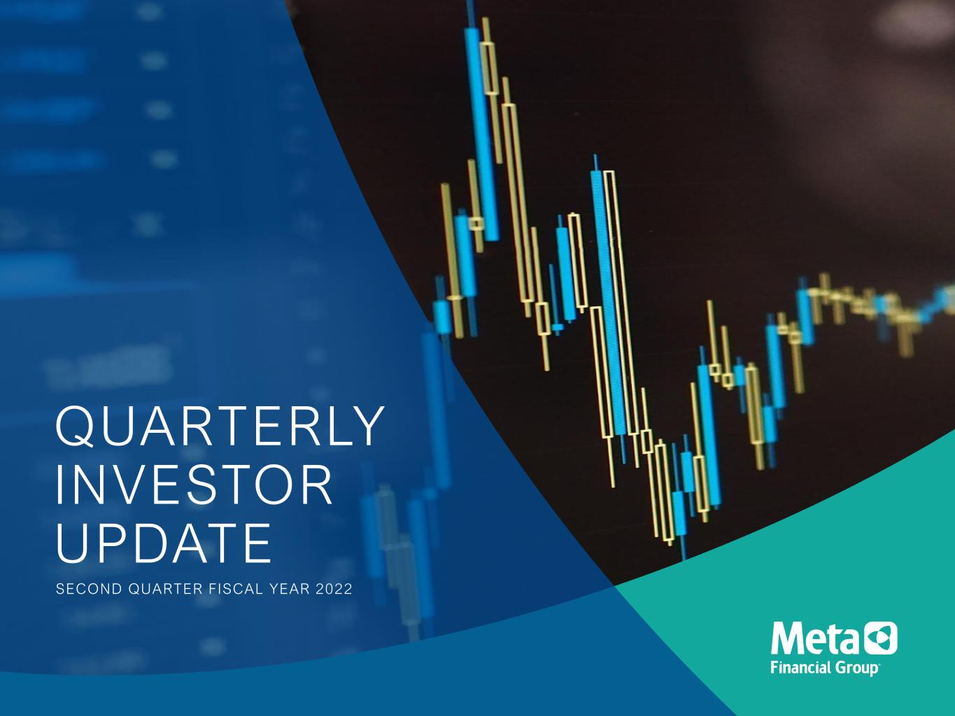
QUARTERLY INVESTOR UPDATE SECOND QUARTER FISCAL YEAR 2022

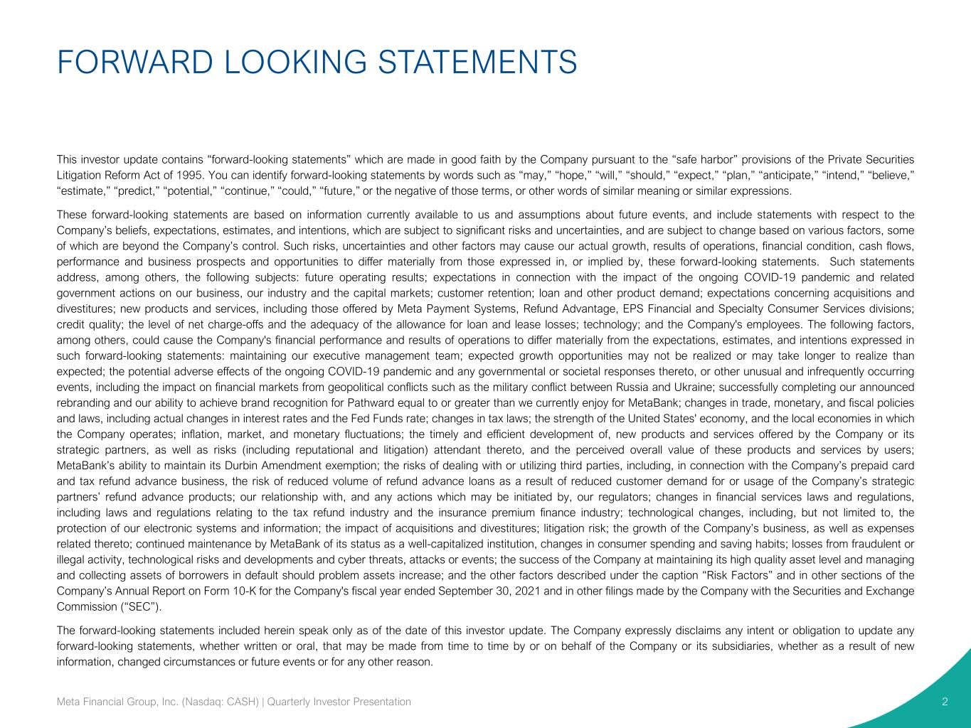
FORWARD LOOKING STATEMENTS 2 This investor update contains “forward-looking statements” which are made in good faith by the Company pursuant to the “safe harbor” provisions of the Private Securities Litigation Reform Act of 1995. You can identify forward-looking statements by words such as “may,” “hope,” “will,” “should,” “expect,” “plan,” “anticipate,” “intend,” “believe,” “estimate,” “predict,” “potential,” “continue,” “could,” “future,” or the negative of those terms, or other words of similar meaning or similar expressions. These forward-looking statements are based on information currently available to us and assumptions about future events, and include statements with respect to the Company’s beliefs, expectations, estimates, and intentions, which are subject to significant risks and uncertainties, and are subject to change based on various factors, some of which are beyond the Company’s control. Such risks, uncertainties and other factors may cause our actual growth, results of operations, financial condition, cash flows, performance and business prospects and opportunities to differ materially from those expressed in, or implied by, these forward-looking statements. Such statements address, among others, the following subjects: future operating results; expectations in connection with the impact of the ongoing COVID-19 pandemic and related government actions on our business, our industry and the capital markets; customer retention; loan and other product demand; expectations concerning acquisitions and divestitures; new products and services, including those offered by Meta Payment Systems, Refund Advantage, EPS Financial and Specialty Consumer Services divisions; credit quality; the level of net charge-offs and the adequacy of the allowance for loan and lease losses; technology; and the Company's employees. The following factors, among others, could cause the Company's financial performance and results of operations to differ materially from the expectations, estimates, and intentions expressed in such forward-looking statements: maintaining our executive management team; expected growth opportunities may not be realized or may take longer to realize than expected; the potential adverse effects of the ongoing COVID-19 pandemic and any governmental or societal responses thereto, or other unusual and infrequently occurring events, including the impact on financial markets from geopolitical conflicts such as the military conflict between Russia and Ukraine; successfully completing our announced rebranding and our ability to achieve brand recognition for Pathward equal to or greater than we currently enjoy for MetaBank; changes in trade, monetary, and fiscal policies and laws, including actual changes in interest rates and the Fed Funds rate; changes in tax laws; the strength of the United States' economy, and the local economies in which the Company operates; inflation, market, and monetary fluctuations; the timely and efficient development of, new products and services offered by the Company or its strategic partners, as well as risks (including reputational and litigation) attendant thereto, and the perceived overall value of these products and services by users; MetaBank’s ability to maintain its Durbin Amendment exemption; the risks of dealing with or utilizing third parties, including, in connection with the Company’s prepaid card and tax refund advance business, the risk of reduced volume of refund advance loans as a result of reduced customer demand for or usage of the Company’s strategic partners’ refund advance products; our relationship with, and any actions which may be initiated by, our regulators; changes in financial services laws and regulations, including laws and regulations relating to the tax refund industry and the insurance premium finance industry; technological changes, including, but not limited to, the protection of our electronic systems and information; the impact of acquisitions and divestitures; litigation risk; the growth of the Company’s business, as well as expenses related thereto; continued maintenance by MetaBank of its status as a well-capitalized institution, changes in consumer spending and saving habits; losses from fraudulent or illegal activity, technological risks and developments and cyber threats, attacks or events; the success of the Company at maintaining its high quality asset level and managing and collecting assets of borrowers in default should problem assets increase; and the other factors described under the caption “Risk Factors” and in other sections of the Company’s Annual Report on Form 10-K for the Company's fiscal year ended September 30, 2021 and in other filings made by the Company with the Securities and Exchange Commission (“SEC”). The forward-looking statements included herein speak only as of the date of this investor update. The Company expressly disclaims any intent or obligation to update any forward-looking statements, whether written or oral, that may be made from time to time by or on behalf of the Company or its subsidiaries, whether as a result of new information, changed circumstances or future events or for any other reason. Meta Financial Group, Inc. (Nasdaq: CASH) | Quarterly Investor Presentation


3 WE STRIVE TO INCREASE FINANCIAL AVAILABILITY, CHOICE, AND OPPORTUNITY THROUGH FINANCIAL EMPOWERMENT. We work to disrupt traditional banking norms by developing partnerships with fintechs, affinity groups, government agencies, and other banks to make a range of quality financial products and services available to the communities we serve nationally. Our national bank charter, coordination with regulators, and deep understanding of risk mitigation and compliance allows us to guide our partners and deliver the financial products and services that meet the needs of those who need them most. We believe in financial inclusion for allTM. Meta Financial Group, Inc. (Nasdaq: CASH) | Quarterly Investor Presentation

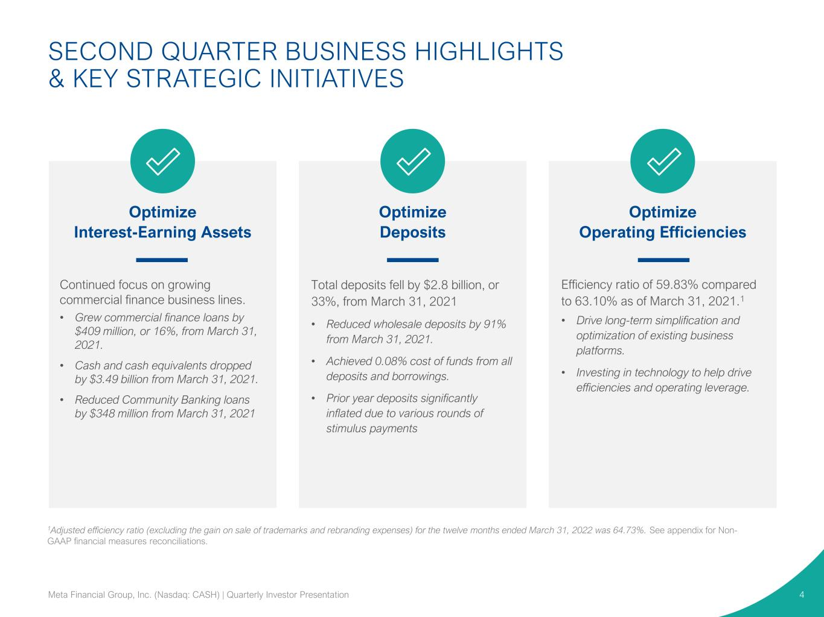
Optimize Interest-Earning Assets Optimize Deposits Optimize Operating Efficiencies Efficiency ratio of 59.83% compared to 63.10% as of March 31, 2021.1 • Drive long-term simplification and optimization of existing business platforms. • Investing in technology to help drive efficiencies and operating leverage. Total deposits fell by $2.8 billion, or 33%, from March 31, 2021 • Reduced wholesale deposits by 91% from March 31, 2021. • Achieved 0.08% cost of funds from all deposits and borrowings. • Prior year deposits significantly inflated due to various rounds of stimulus payments Continued focus on growing commercial finance business lines. • Grew commercial finance loans by $409 million, or 16%, from March 31, 2021. • Cash and cash equivalents dropped by $3.49 billion from March 31, 2021. • Reduced Community Banking loans by $348 million from March 31, 2021 SECOND QUARTER BUSINESS HIGHLIGHTS & KEY STRATEGIC INITIATIVES 4Meta Financial Group, Inc. (Nasdaq: CASH) | Quarterly Investor Presentation 1Adjusted efficiency ratio (excluding the gain on sale of trademarks and rebranding expenses) for the twelve months ended March 31, 2022 was 64.73%. See appendix for Non- GAAP financial measures reconciliations.

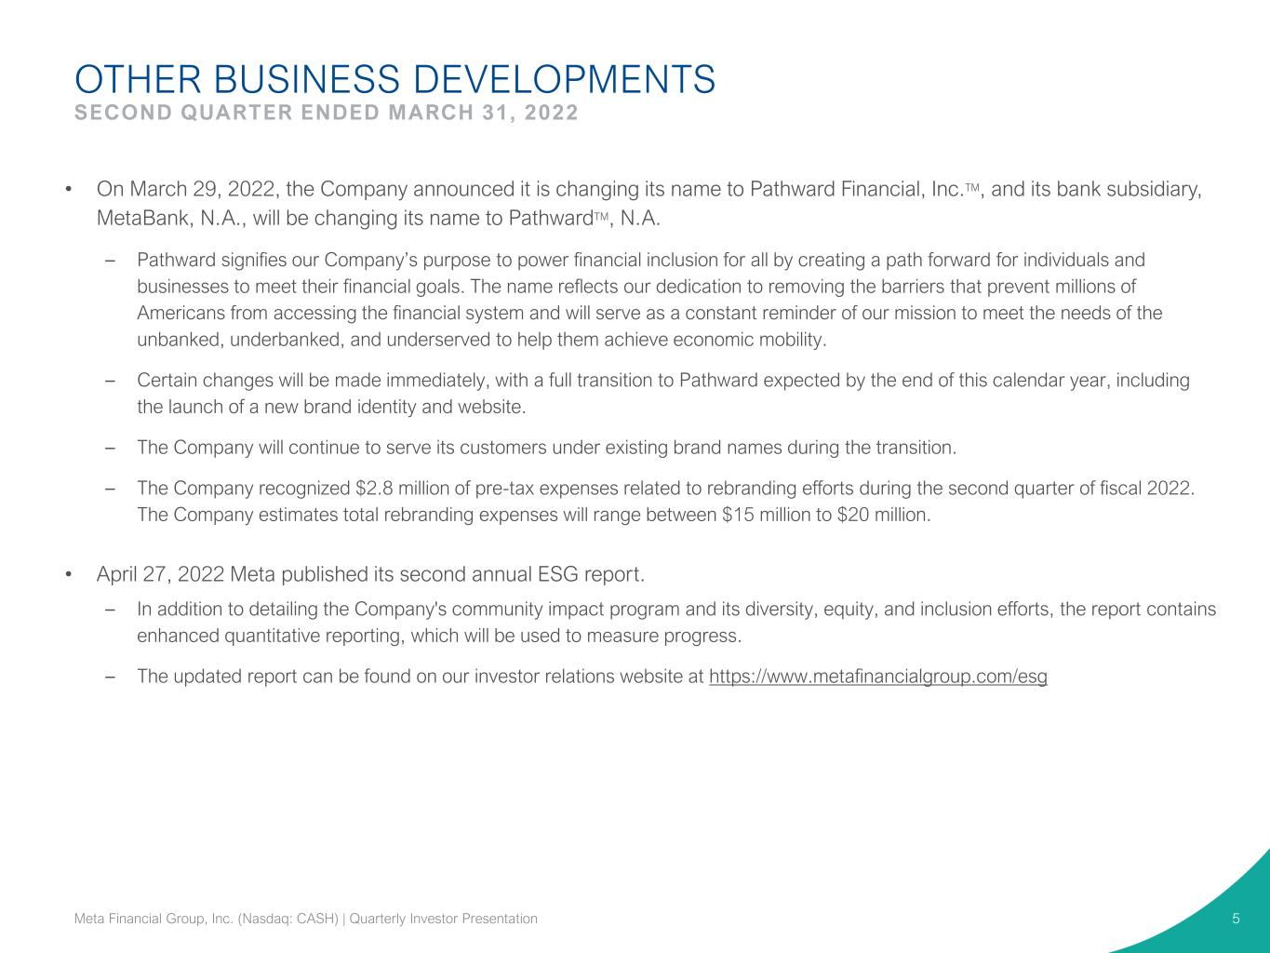
OTHER BUSINESS DEVELOPMENTS SECOND QUARTER ENDED MARCH 31, 2022 5Meta Financial Group, Inc. (Nasdaq: CASH) | Quarterly Investor Presentation • On March 29, 2022, the Company announced it is changing its name to Pathward Financial, Inc.TM, and its bank subsidiary, MetaBank, N.A., will be changing its name to PathwardTM, N.A. – Pathward signifies our Company’s purpose to power financial inclusion for all by creating a path forward for individuals and businesses to meet their financial goals. The name reflects our dedication to removing the barriers that prevent millions of Americans from accessing the financial system and will serve as a constant reminder of our mission to meet the needs of the unbanked, underbanked, and underserved to help them achieve economic mobility. – Certain changes will be made immediately, with a full transition to Pathward expected by the end of this calendar year, including the launch of a new brand identity and website. – The Company will continue to serve its customers under existing brand names during the transition. – The Company recognized $2.8 million of pre-tax expenses related to rebranding efforts during the second quarter of fiscal 2022. The Company estimates total rebranding expenses will range between $15 million to $20 million. • April 27, 2022 Meta published its second annual ESG report. – In addition to detailing the Company's community impact program and its diversity, equity, and inclusion efforts, the report contains enhanced quantitative reporting, which will be used to measure progress. – The updated report can be found on our investor relations website at https://www.metafinancialgroup.com/esg

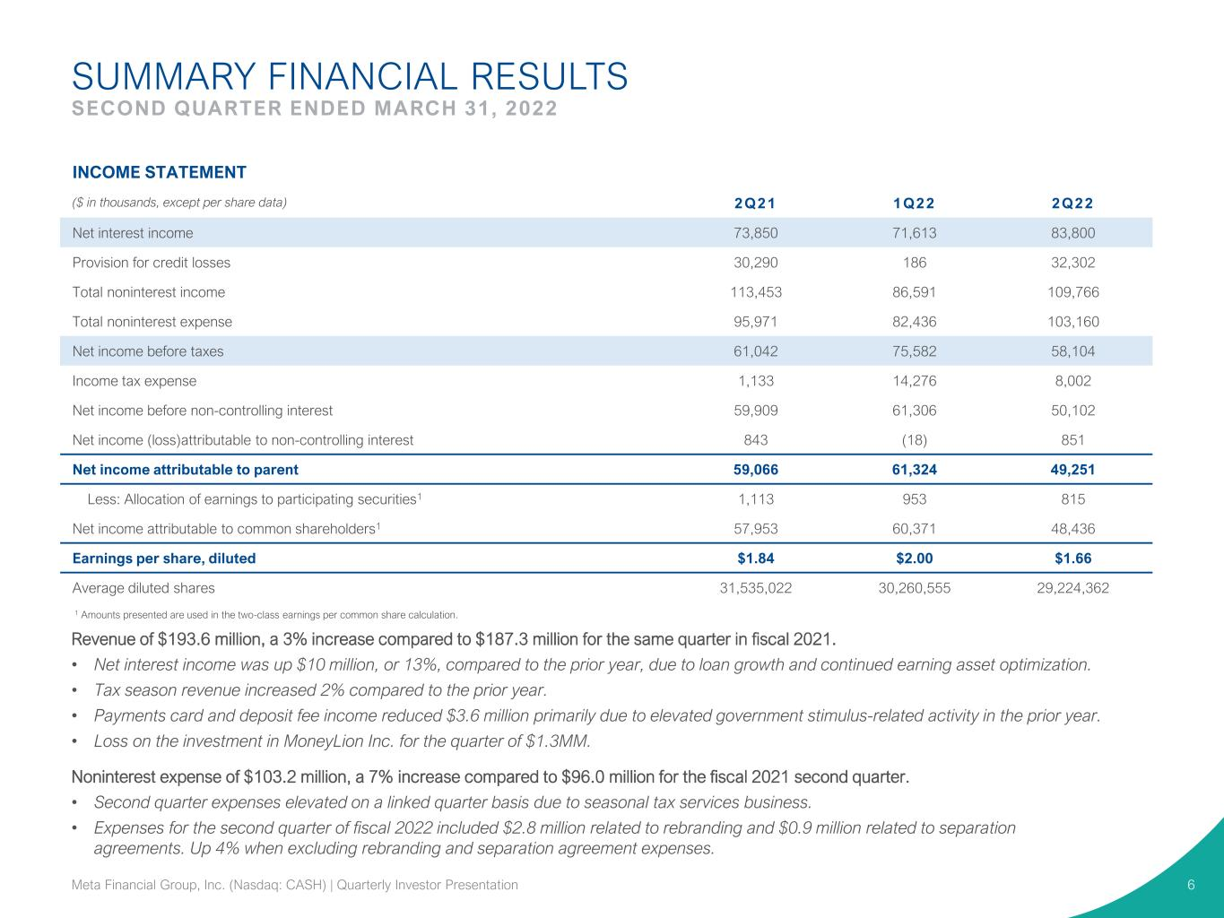
SUMMARY FINANCIAL RESULTS SECOND QUARTER ENDED MARCH 31, 2022 6 1 Amounts presented are used in the two-class earnings per common share calculation. INCOME STATEMENT ($ in thousands, except per share data) 2Q21 1Q22 2Q22 Net interest income 73,850 71,613 83,800 Provision for credit losses 30,290 186 32,302 Total noninterest income 113,453 86,591 109,766 Total noninterest expense 95,971 82,436 103,160 Net income before taxes 61,042 75,582 58,104 Income tax expense 1,133 14,276 8,002 Net income before non-controlling interest 59,909 61,306 50,102 Net income (loss)attributable to non-controlling interest 843 (18) 851 Net income attributable to parent 59,066 61,324 49,251 Less: Allocation of earnings to participating securities1 1,113 953 815 Net income attributable to common shareholders1 57,953 60,371 48,436 Earnings per share, diluted $1.84 $2.00 $1.66 Average diluted shares 31,535,022 30,260,555 29,224,362 Revenue of $193.6 million, a 3% increase compared to $187.3 million for the same quarter in fiscal 2021. • Net interest income was up $10 million, or 13%, compared to the prior year, due to loan growth and continued earning asset optimization. • Tax season revenue increased 2% compared to the prior year. • Payments card and deposit fee income reduced $3.6 million primarily due to elevated government stimulus-related activity in the prior year. • Loss on the investment in MoneyLion Inc. for the quarter of $1.3MM. Noninterest expense of $103.2 million, a 7% increase compared to $96.0 million for the fiscal 2021 second quarter. • Second quarter expenses elevated on a linked quarter basis due to seasonal tax services business. • Expenses for the second quarter of fiscal 2022 included $2.8 million related to rebranding and $0.9 million related to separation agreements. Up 4% when excluding rebranding and separation agreement expenses. Meta Financial Group, Inc. (Nasdaq: CASH) | Quarterly Investor Presentation

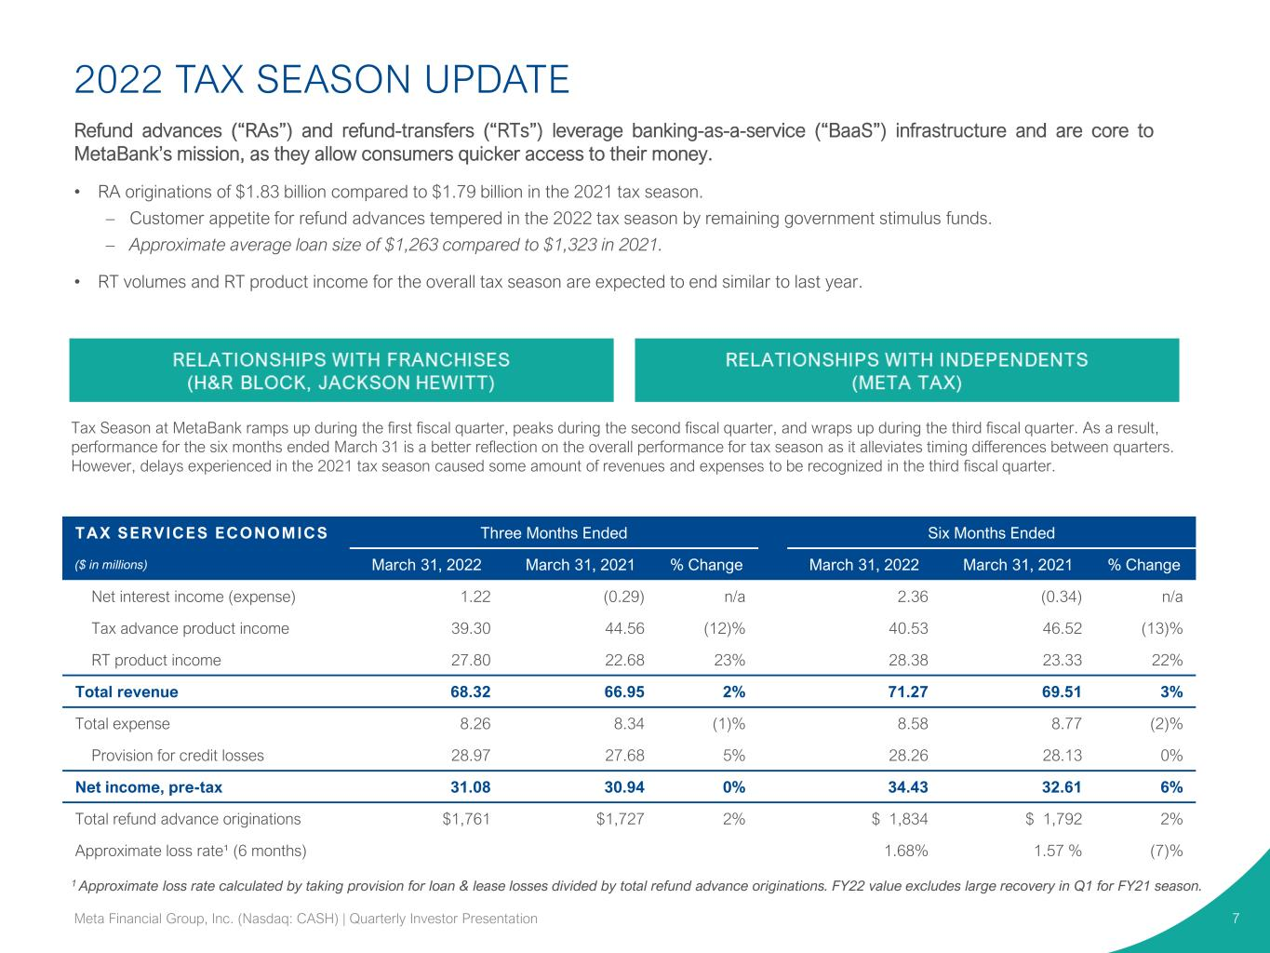
2022 TAX SEASON UPDATE 7 Refund advances (“RAs”) and refund-transfers (“RTs”) leverage banking-as-a-service (“BaaS”) infrastructure and are core to MetaBank’s mission, as they allow consumers quicker access to their money. • RA originations of $1.83 billion compared to $1.79 billion in the 2021 tax season. – Customer appetite for refund advances tempered in the 2022 tax season by remaining government stimulus funds. – Approximate average loan size of $1,263 compared to $1,323 in 2021. • RT volumes and RT product income for the overall tax season are expected to end similar to last year. Meta Financial Group, Inc. (Nasdaq: CASH) | Quarterly Investor Presentation Tax Season at MetaBank ramps up during the first fiscal quarter, peaks during the second fiscal quarter, and wraps up during the third fiscal quarter. As a result, performance for the six months ended March 31 is a better reflection on the overall performance for tax season as it alleviates timing differences between quarters. However, delays experienced in the 2021 tax season caused some amount of revenues and expenses to be recognized in the third fiscal quarter. TAX SERVICES ECONOMICS Three Months Ended Six Months Ended ($ in millions) March 31, 2022 March 31, 2021 % Change March 31, 2022 March 31, 2021 % Change Net interest income (expense) 1.22 (0.29) n/a 2.36 (0.34) n/a Tax advance product income 39.30 44.56 (12)% 40.53 46.52 (13)% RT product income 27.80 22.68 23% 28.38 23.33 22% Total revenue 68.32 66.95 2% 71.27 69.51 3% Total expense 8.26 8.34 (1)% 8.58 8.77 (2)% Provision for credit losses 28.97 27.68 5% 28.26 28.13 0% Net income, pre-tax 31.08 30.94 0% 34.43 32.61 6% Total refund advance originations $1,761 $1,727 2% $ 1,834 $ 1,792 2% Approximate loss rate¹ (6 months) 1.68% 1.57 % (7)% 1 Approximate loss rate calculated by taking provision for loan & lease losses divided by total refund advance originations. FY22 value excludes large recovery in Q1 for FY21 season.

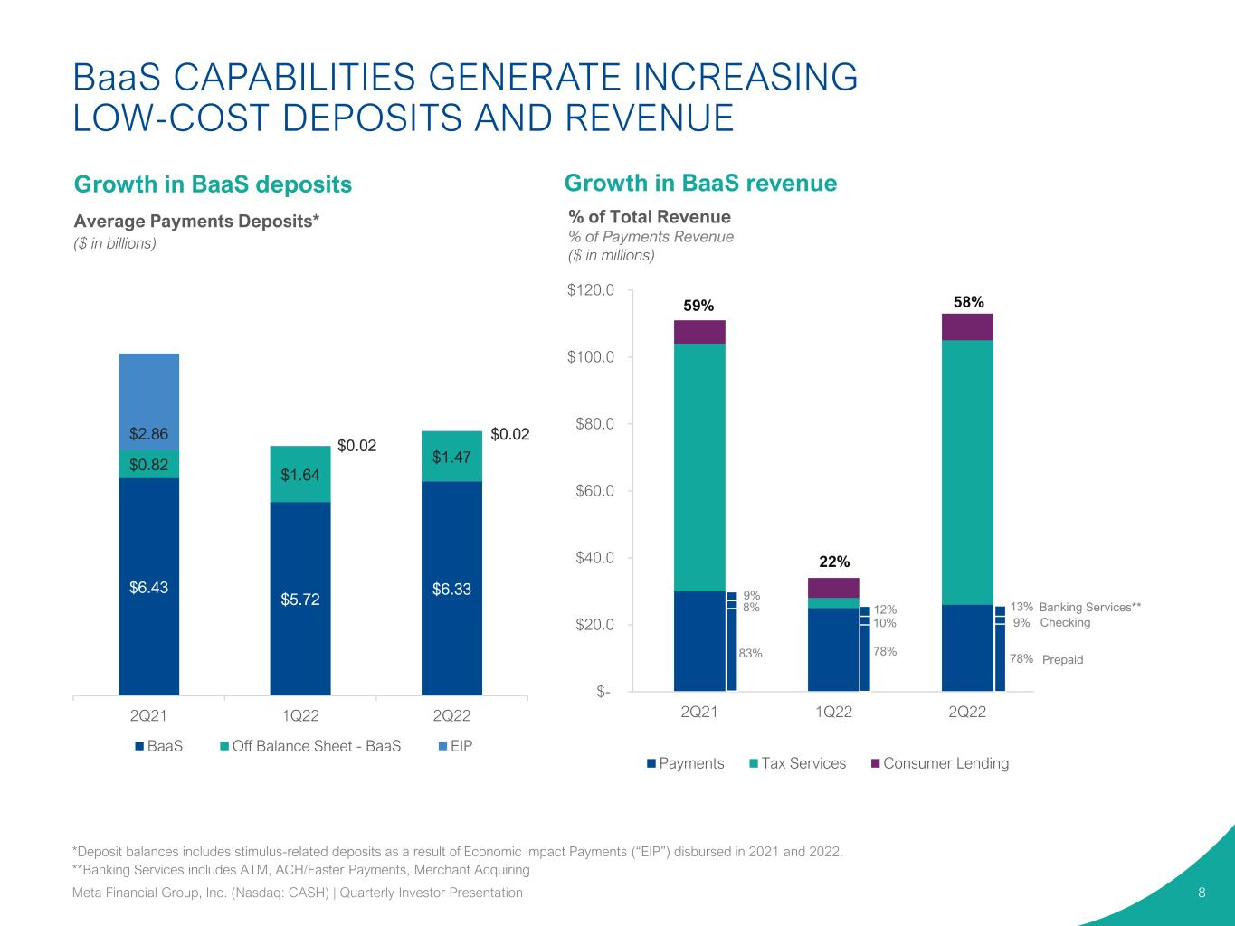
$- $20.0 $40.0 $60.0 $80.0 $100.0 $120.0 2Q21 1Q22 2Q22 Payments Tax Services Consumer Lending BaaS CAPABILITIES GENERATE INCREASING LOW-COST DEPOSITS AND REVENUE 8 Growth in BaaS revenue Average Payments Deposits* ($ in billions) 59% 22% 58% % of Total Revenue % of Payments Revenue ($ in millions) *Deposit balances includes stimulus-related deposits as a result of Economic Impact Payments (“EIP”) disbursed in 2021 and 2022. **Banking Services includes ATM, ACH/Faster Payments, Merchant Acquiring Growth in BaaS deposits Banking Services** Checking Prepaid 13% 9% 78% Meta Financial Group, Inc. (Nasdaq: CASH) | Quarterly Investor Presentation 9% 8% 83% 12% 10% 78% $6.43 $5.72 $6.33 $0.82 $1.64 $1.47 $2.86 $0.02 $0.02 2Q21 1Q22 2Q22 BaaS Off Balance Sheet - BaaS EIP

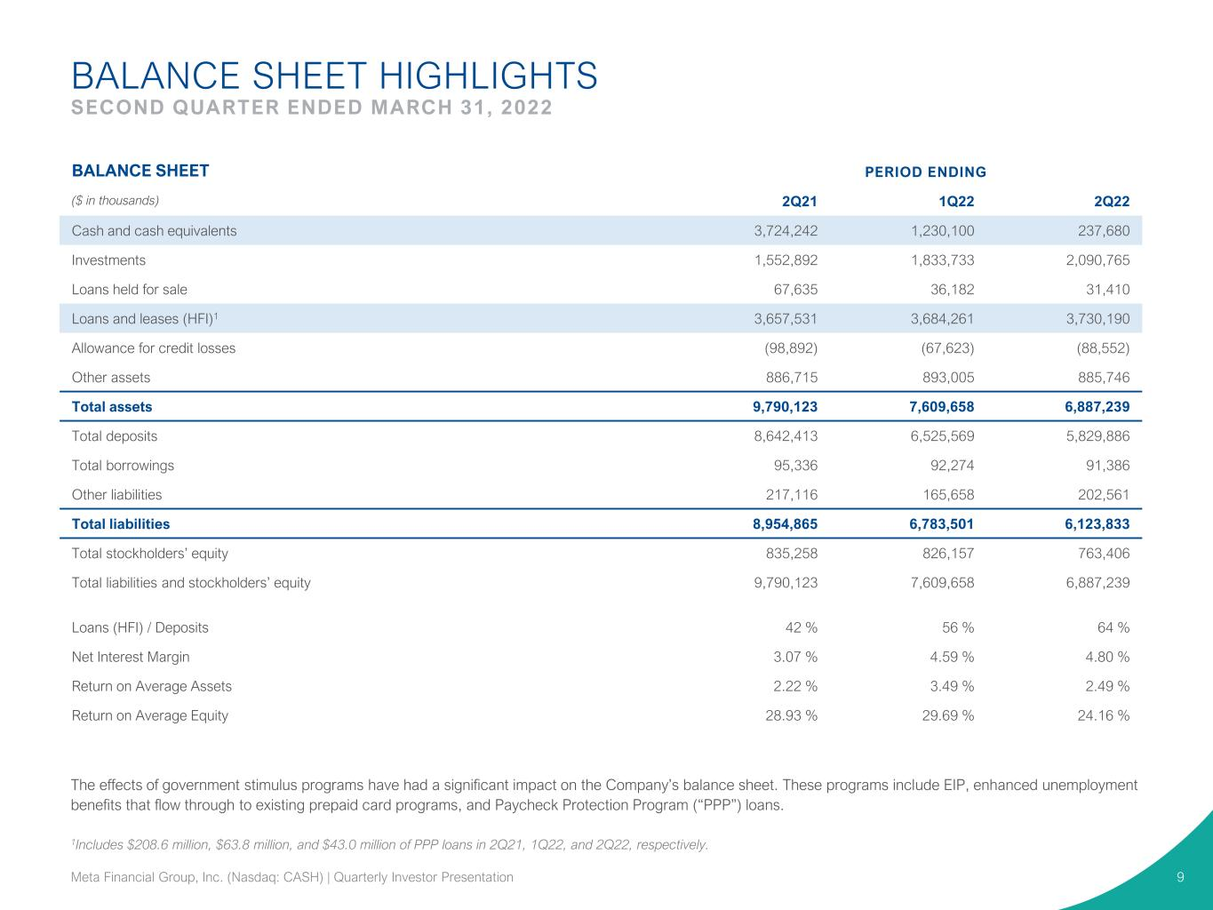
BALANCE SHEET HIGHLIGHTS SECOND QUARTER ENDED MARCH 31, 2022 9 BALANCE SHEET PERIOD ENDING ($ in thousands) 2Q21 1Q22 2Q22 Cash and cash equivalents 3,724,242 1,230,100 237,680 Investments 1,552,892 1,833,733 2,090,765 Loans held for sale 67,635 36,182 31,410 Loans and leases (HFI)1 3,657,531 3,684,261 3,730,190 Allowance for credit losses (98,892) (67,623) (88,552) Other assets 886,715 893,005 885,746 Total assets 9,790,123 7,609,658 6,887,239 Total deposits 8,642,413 6,525,569 5,829,886 Total borrowings 95,336 92,274 91,386 Other liabilities 217,116 165,658 202,561 Total liabilities 8,954,865 6,783,501 6,123,833 Total stockholders’ equity 835,258 826,157 763,406 Total liabilities and stockholders’ equity 9,790,123 7,609,658 6,887,239 Loans (HFI) / Deposits 42 % 56 % 64 % Net Interest Margin 3.07 % 4.59 % 4.80 % Return on Average Assets 2.22 % 3.49 % 2.49 % Return on Average Equity 28.93 % 29.69 % 24.16 % 1Includes $208.6 million, $63.8 million, and $43.0 million of PPP loans in 2Q21, 1Q22, and 2Q22, respectively. The effects of government stimulus programs have had a significant impact on the Company’s balance sheet. These programs include EIP, enhanced unemployment benefits that flow through to existing prepaid card programs, and Paycheck Protection Program (“PPP”) loans. Meta Financial Group, Inc. (Nasdaq: CASH) | Quarterly Investor Presentation

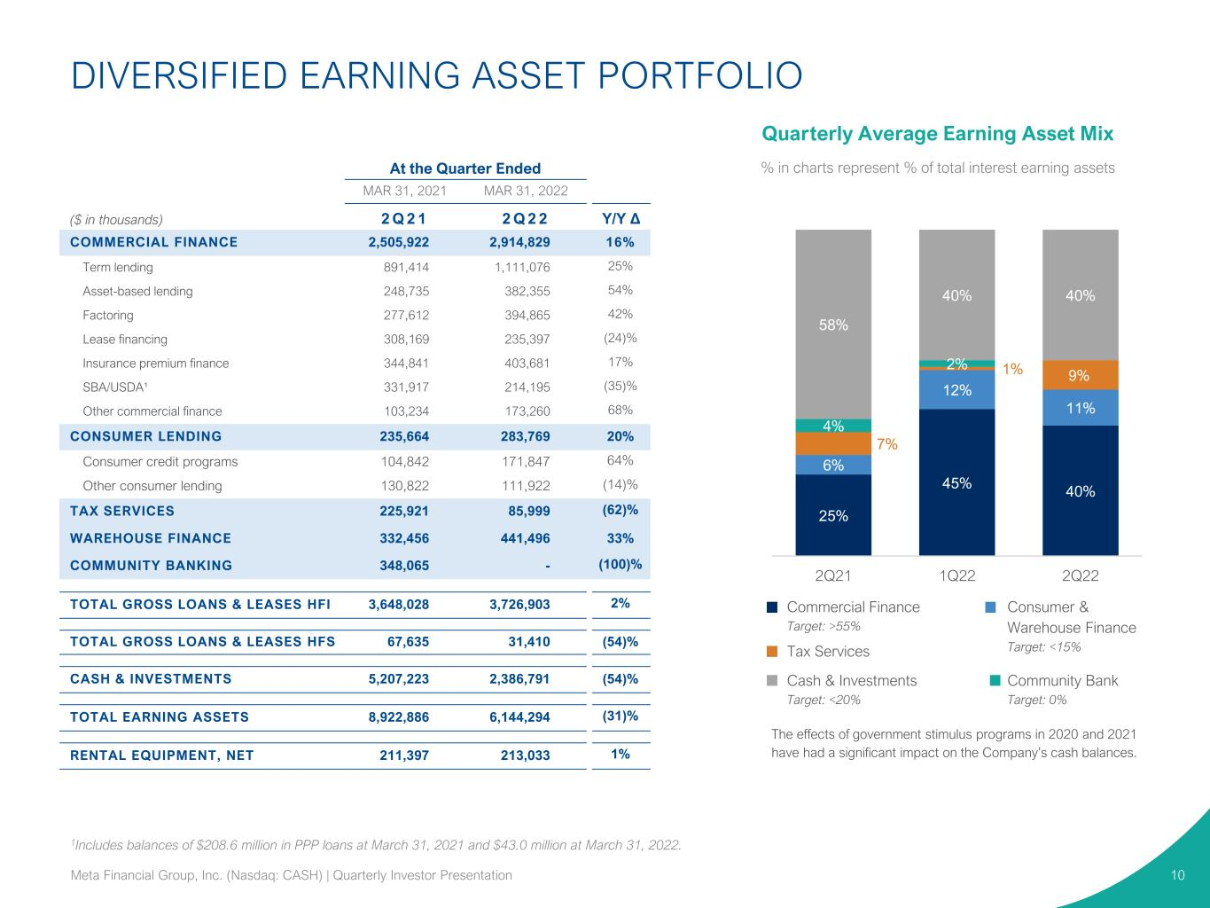
Quarterly Average Earning Asset Mix % in charts represent % of total interest earning assetsAt the Quarter Ended MAR 31, 2021 MAR 31, 2022 ($ in thousands) 2 Q 2 1 2 Q 2 2 Y/Y Δ COMMERCIAL FINANCE 2,505,922 2,914,829 16% Term lending 891,414 1,111,076 25% Asset-based lending 248,735 382,355 54% Factoring 277,612 394,865 42% Lease financing 308,169 235,397 (24)% Insurance premium finance 344,841 403,681 17% SBA/USDA¹ 331,917 214,195 (35)% Other commercial finance 103,234 173,260 68% CONSUMER LENDING 235,664 283,769 20% Consumer credit programs 104,842 171,847 64% Other consumer lending 130,822 111,922 (14)% TAX SERVICES 225,921 85,999 (62)% WAREHOUSE FINANCE 332,456 441,496 33% COMMUNITY BANKING 348,065 - (100)% TOTAL GROSS LOANS & LEASES HFI 3,648,028 3,726,903 2% TOTAL GROSS LOANS & LEASES HFS 67,635 31,410 (54)% CASH & INVESTMENTS 5,207,223 2,386,791 (54)% TOTAL EARNING ASSETS 8,922,886 6,144,294 (31)% RENTAL EQUIPMENT, NET 211,397 213,033 1% 1Includes balances of $208.6 million in PPP loans at March 31, 2021 and $43.0 million at March 31, 2022. DIVERSIFIED EARNING ASSET PORTFOLIO 10 25% 45% 40% 6% 12% 11% 7% 1% 9% 4% 2% 58% 40% 40% 2Q21 1Q22 2Q22 Commercial Finance Target: >55% Consumer & Warehouse Finance Target: <15%Tax Services Community Bank Target: 0% Cash & Investments Target: <20% The effects of government stimulus programs in 2020 and 2021 have had a significant impact on the Company’s cash balances. Meta Financial Group, Inc. (Nasdaq: CASH) | Quarterly Investor Presentation

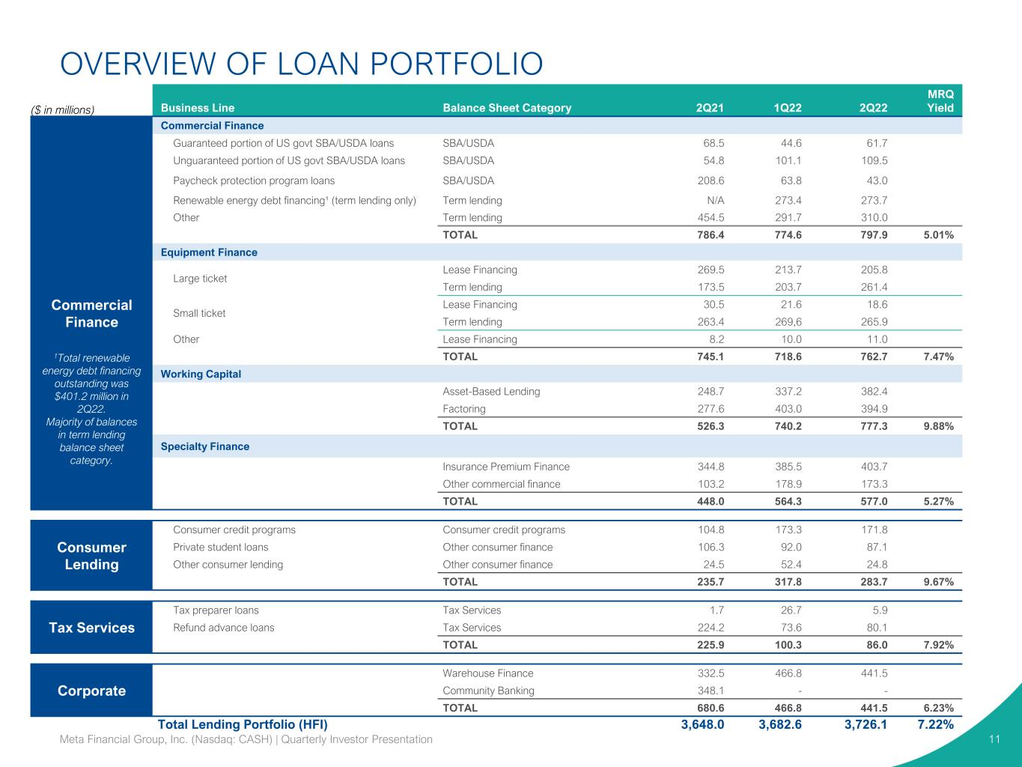
OVERVIEW OF LOAN PORTFOLIO 11 ($ in millions) Business Line Balance Sheet Category 2Q21 1Q22 2Q22 MRQ Yield Commercial Finance Commercial Finance Guaranteed portion of US govt SBA/USDA loans SBA/USDA 68.5 44.6 61.7 Unguaranteed portion of US govt SBA/USDA loans SBA/USDA 54.8 101.1 109.5 Paycheck protection program loans SBA/USDA 208.6 63.8 43.0 Renewable energy debt financing¹ (term lending only) Term lending N/A 273.4 273.7 Other Term lending 454.5 291.7 310.0 TOTAL 786.4 774.6 797.9 5.01% Equipment Finance Large ticket Lease Financing 269.5 213.7 205.8 Term lending 173.5 203.7 261.4 Small ticket Lease Financing 30.5 21.6 18.6 Term lending 263.4 269,6 265.9 Other Lease Financing 8.2 10.0 11.0 TOTAL 745.1 718.6 762.7 7.47% Working Capital Asset-Based Lending 248.7 337.2 382.4 Factoring 277.6 403.0 394.9 TOTAL 526.3 740.2 777.3 9.88% Specialty Finance Insurance Premium Finance 344.8 385.5 403.7 Other commercial finance 103.2 178.9 173.3 TOTAL 448.0 564.3 577.0 5.27% Consumer Lending Consumer credit programs Consumer credit programs 104.8 173.3 171.8 Private student loans Other consumer finance 106.3 92.0 87.1 Other consumer lending Other consumer finance 24.5 52.4 24.8 TOTAL 235.7 317.8 283.7 9.67% Tax Services Tax preparer loans Tax Services 1.7 26.7 5.9 Refund advance loans Tax Services 224.2 73.6 80.1 TOTAL 225.9 100.3 86.0 7.92% Corporate Warehouse Finance 332.5 466.8 441.5 Community Banking 348.1 - - TOTAL 680.6 466.8 441.5 6.23% Total Lending Portfolio (HFI) 3,648.0 3,682.6 3,726.1 7.22% Meta Financial Group, Inc. (Nasdaq: CASH) | Quarterly Investor Presentation 1Total renewable energy debt financing outstanding was $401.2 million in 2Q22. Majority of balances in term lending balance sheet category.

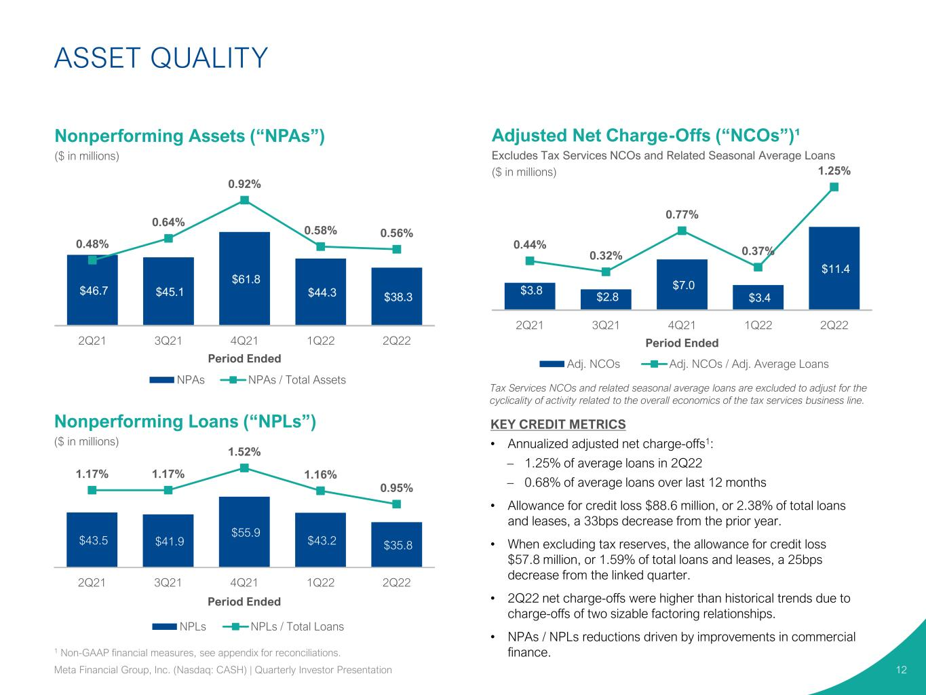
$3.8 $2.8 $7.0 $3.4 $11.4 0.44% 0.32% 0.77% 0.37% 1.25% 2Q21 3Q21 4Q21 1Q22 2Q22 Period Ended Adj. NCOs Adj. NCOs / Adj. Average Loans Adjusted Net Charge-Offs (“NCOs”)¹ Excludes Tax Services NCOs and Related Seasonal Average Loans ($ in millions) KEY CREDIT METRICS • Annualized adjusted net charge-offs1: – 1.25% of average loans in 2Q22 – 0.68% of average loans over last 12 months • Allowance for credit loss $88.6 million, or 2.38% of total loans and leases, a 33bps decrease from the prior year. • When excluding tax reserves, the allowance for credit loss $57.8 million, or 1.59% of total loans and leases, a 25bps decrease from the linked quarter. • 2Q22 net charge-offs were higher than historical trends due to charge-offs of two sizable factoring relationships. • NPAs / NPLs reductions driven by improvements in commercial finance. $46.7 $45.1 $61.8 $44.3 $38.3 0.48% 0.64% 0.92% 0.58% 0.56% 2Q21 3Q21 4Q21 1Q22 2Q22 Period Ended NPAs NPAs / Total Assets ASSET QUALITY 12 1 Non-GAAP financial measures, see appendix for reconciliations. Tax Services NCOs and related seasonal average loans are excluded to adjust for the cyclicality of activity related to the overall economics of the tax services business line. $43.5 $41.9 $55.9 $43.2 $35.8 1.17% 1.17% 1.52% 1.16% 0.95% 2Q21 3Q21 4Q21 1Q22 2Q22 Period Ended NPLs NPLs / Total Loans Nonperforming Assets (“NPAs”) ($ in millions) Nonperforming Loans (“NPLs”) ($ in millions) Meta Financial Group, Inc. (Nasdaq: CASH) | Quarterly Investor Presentation

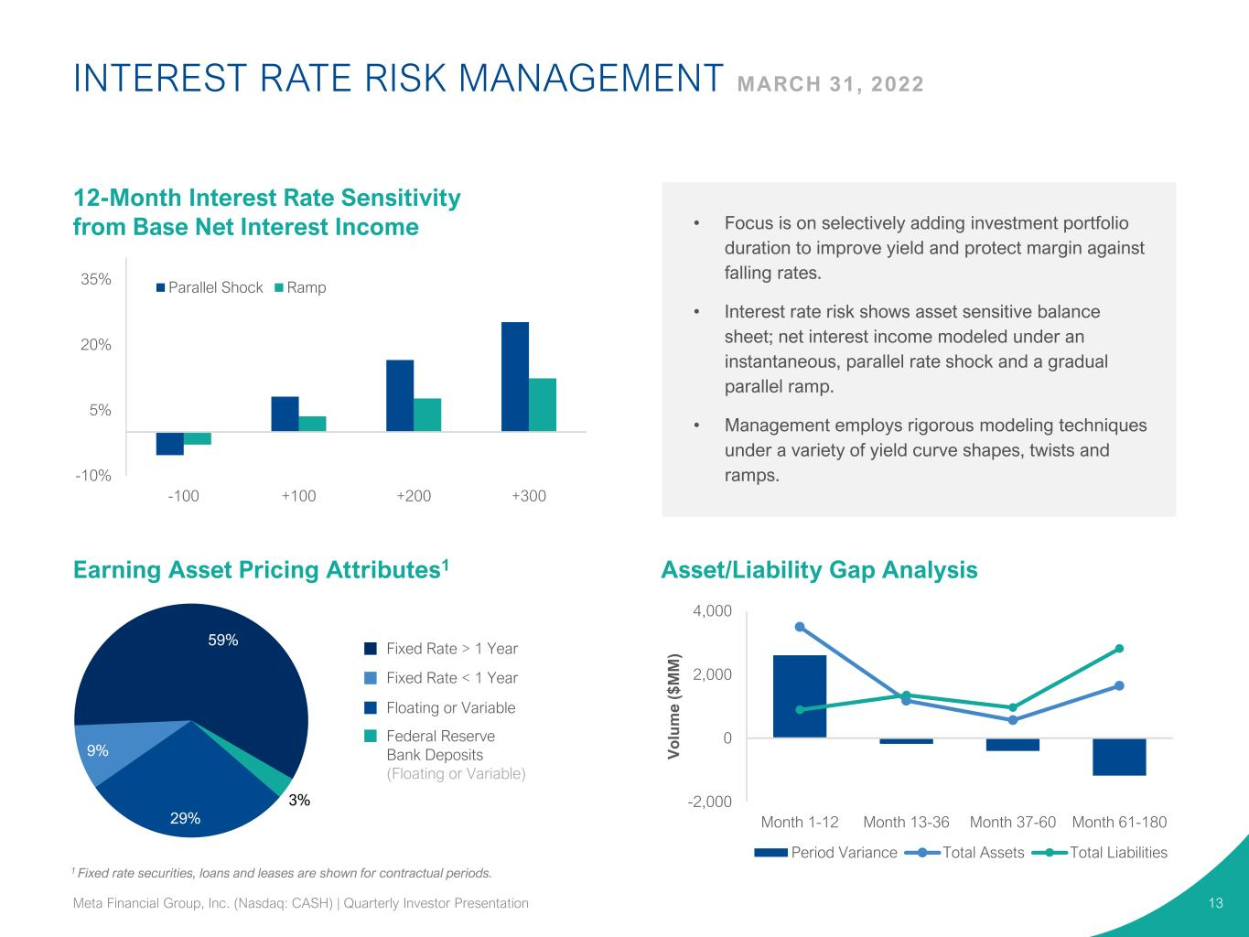
-10% 5% 20% 35% -100 +100 +200 +300 Parallel Shock Ramp 1 Fixed rate securities, loans and leases are shown for contractual periods. -2,000 0 2,000 4,000 Month 1-12 Month 13-36 Month 37-60 Month 61-180 V o lu m e ( $ M M ) Period Variance Total Assets Total Liabilities INTEREST RATE RISK MANAGEMENT MARCH 31, 2022 13 3% 29% 9% 59% • Focus is on selectively adding investment portfolio duration to improve yield and protect margin against falling rates. • Interest rate risk shows asset sensitive balance sheet; net interest income modeled under an instantaneous, parallel rate shock and a gradual parallel ramp. • Management employs rigorous modeling techniques under a variety of yield curve shapes, twists and ramps. Fixed Rate > 1 Year 12-Month Interest Rate Sensitivity from Base Net Interest Income Earning Asset Pricing Attributes1 Asset/Liability Gap Analysis Fixed Rate < 1 Year Floating or Variable Federal Reserve Bank Deposits (Floating or Variable) Meta Financial Group, Inc. (Nasdaq: CASH) | Quarterly Investor Presentation

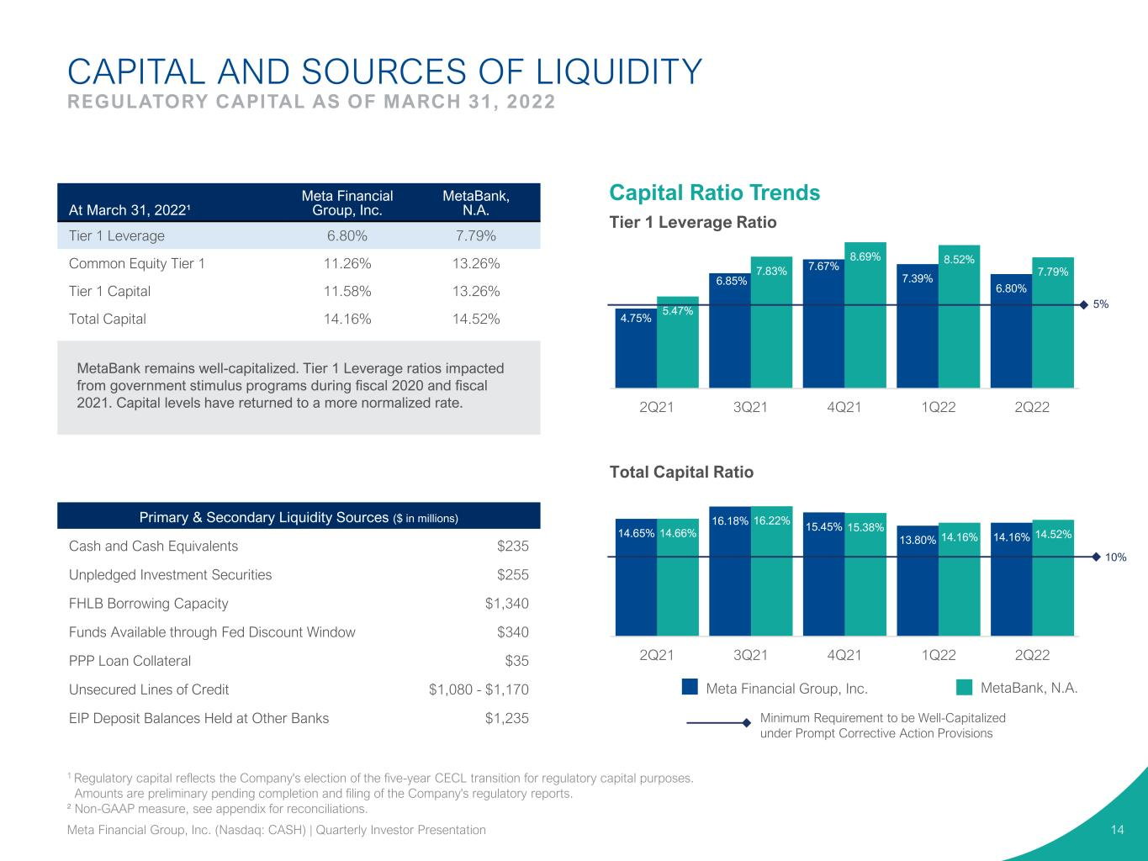
4.75% 6.85% 7.67% 7.39% 6.80% 5.47% 7.83% 8.69% 8.52% 7.79% 2Q21 3Q21 4Q21 1Q22 2Q22 CAPITAL AND SOURCES OF LIQUIDITY REGULATORY CAPITAL AS OF MARCH 31, 2022 Minimum Requirement to be Well-Capitalized under Prompt Corrective Action Provisions Meta Financial Group, Inc. MetaBank, N.A. Capital Ratio Trends At March 31, 2022¹ Meta Financial Group, Inc. MetaBank, N.A. Tier 1 Leverage 6.80% 7.79% Common Equity Tier 1 11.26% 13.26% Tier 1 Capital 11.58% 13.26% Total Capital 14.16% 14.52% MetaBank remains well-capitalized. Tier 1 Leverage ratios impacted from government stimulus programs during fiscal 2020 and fiscal 2021. Capital levels have returned to a more normalized rate. Primary & Secondary Liquidity Sources ($ in millions) Cash and Cash Equivalents $235 Unpledged Investment Securities $255 FHLB Borrowing Capacity $1,340 Funds Available through Fed Discount Window $340 PPP Loan Collateral $35 Unsecured Lines of Credit $1,080 - $1,170 EIP Deposit Balances Held at Other Banks $1,235 14.65% 16.18% 15.45% 13.80% 14.16%14.66% 16.22% 15.38% 14.16% 14.52% 2Q21 3Q21 4Q21 1Q22 2Q22 10% 5% 14 Total Capital Ratio Tier 1 Leverage Ratio 1 Regulatory capital reflects the Company's election of the five-year CECL transition for regulatory capital purposes. Amounts are preliminary pending completion and filing of the Company's regulatory reports. ² Non-GAAP measure, see appendix for reconciliations. Meta Financial Group, Inc. (Nasdaq: CASH) | Quarterly Investor Presentation

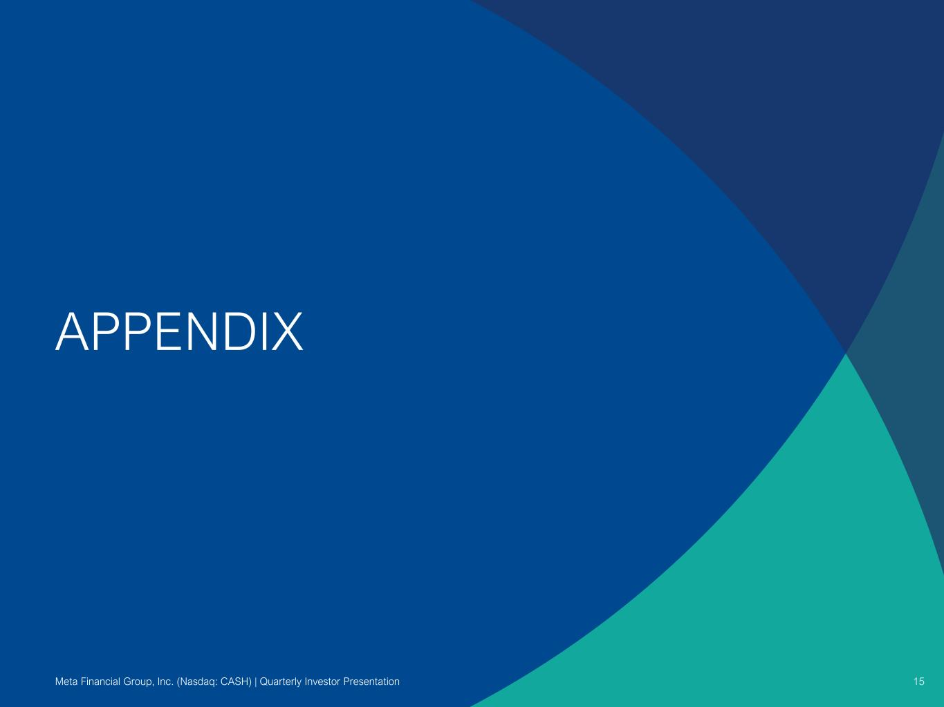
APPENDIX 15Meta Financial Group, Inc. (Nasdaq: CASH) | Quarterly Investor Presentation

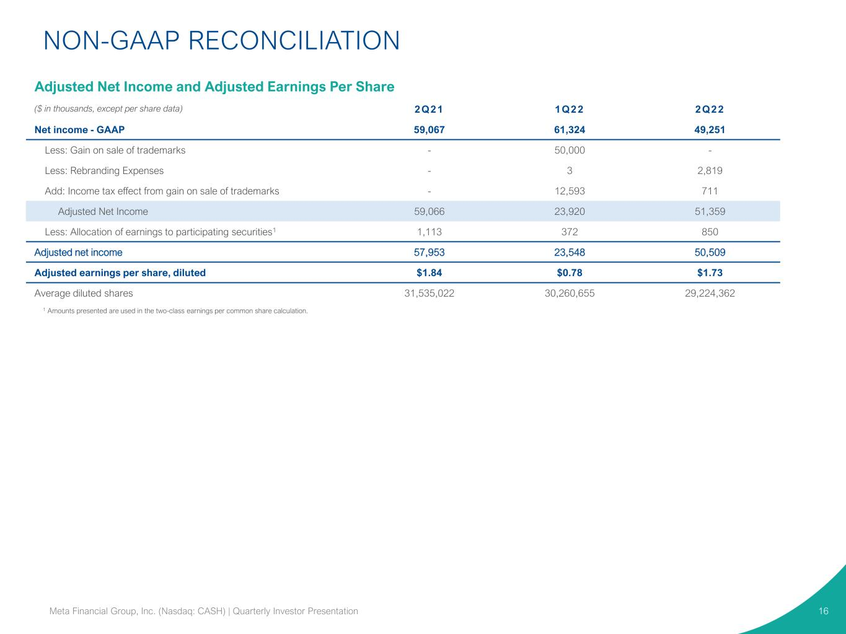
NON-GAAP RECONCILIATION 16Meta Financial Group, Inc. (Nasdaq: CASH) | Quarterly Investor Presentation Adjusted Net Income and Adjusted Earnings Per Share ($ in thousands, except per share data) 2Q21 1Q22 2Q22 Net income - GAAP 59,067 61,324 49,251 Less: Gain on sale of trademarks - 50,000 - Less: Rebranding Expenses - 3 2,819 Add: Income tax effect from gain on sale of trademarks - 12,593 711 Adjusted Net Income 59,066 23,920 51,359 Less: Allocation of earnings to participating securities1 1,113 372 850 Adjusted net income 57,953 23,548 50,509 Adjusted earnings per share, diluted $1.84 $0.78 $1.73 Average diluted shares 31,535,022 30,260,655 29,224,362 1 Amounts presented are used in the two-class earnings per common share calculation.

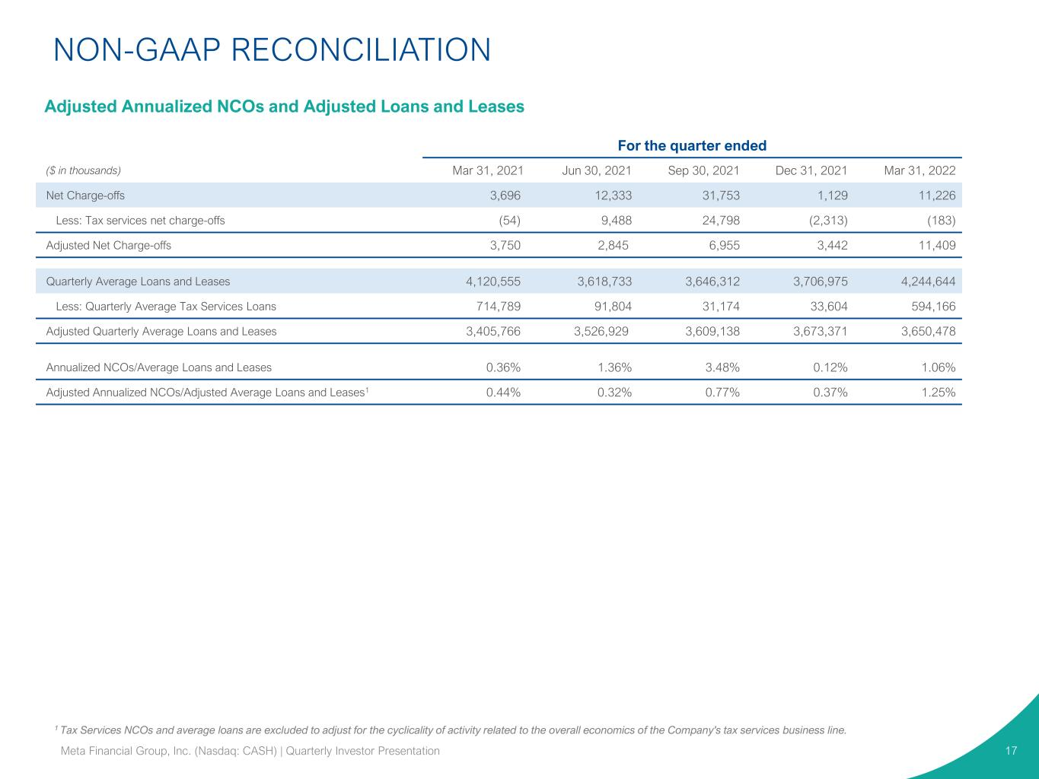
1 Tax Services NCOs and average loans are excluded to adjust for the cyclicality of activity related to the overall economics of the Company's tax services business line. 17 For the quarter ended ($ in thousands) Mar 31, 2021 Jun 30, 2021 Sep 30, 2021 Dec 31, 2021 Mar 31, 2022 Net Charge-offs 3,696 12,333 31,753 1,129 11,226 Less: Tax services net charge-offs (54) 9,488 24,798 (2,313) (183) Adjusted Net Charge-offs 3,750 2,845 6,955 3,442 11,409 Quarterly Average Loans and Leases 4,120,555 3,618,733 3,646,312 3,706,975 4,244,644 Less: Quarterly Average Tax Services Loans 714,789 91,804 31,174 33,604 594,166 Adjusted Quarterly Average Loans and Leases 3,405,766 3,526,929 3,609,138 3,673,371 3,650,478 Annualized NCOs/Average Loans and Leases 0.36% 1.36% 3.48% 0.12% 1.06% Adjusted Annualized NCOs/Adjusted Average Loans and Leases1 0.44% 0.32% 0.77% 0.37% 1.25% Meta Financial Group, Inc. (Nasdaq: CASH) | Quarterly Investor Presentation NON-GAAP RECONCILIATION Adjusted Annualized NCOs and Adjusted Loans and Leases

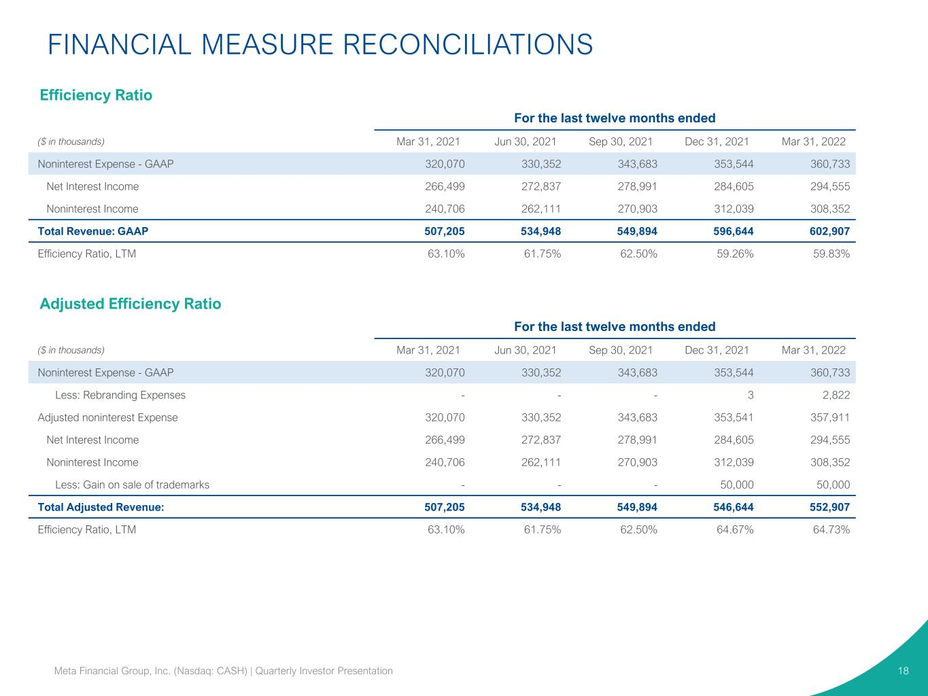
FINANCIAL MEASURE RECONCILIATIONS 18Meta Financial Group, Inc. (Nasdaq: CASH) | Quarterly Investor Presentation For the last twelve months ended ($ in thousands) Mar 31, 2021 Jun 30, 2021 Sep 30, 2021 Dec 31, 2021 Mar 31, 2022 Noninterest Expense - GAAP 320,070 330,352 343,683 353,544 360,733 Net Interest Income 266,499 272,837 278,991 284,605 294,555 Noninterest Income 240,706 262,111 270,903 312,039 308,352 Total Revenue: GAAP 507,205 534,948 549,894 596,644 602,907 Efficiency Ratio, LTM 63.10% 61.75% 62.50% 59.26% 59.83% For the last twelve months ended ($ in thousands) Mar 31, 2021 Jun 30, 2021 Sep 30, 2021 Dec 31, 2021 Mar 31, 2022 Noninterest Expense - GAAP 320,070 330,352 343,683 353,544 360,733 Less: Rebranding Expenses - - - 3 2,822 Adjusted noninterest Expense 320,070 330,352 343,683 353,541 357,911 Net Interest Income 266,499 272,837 278,991 284,605 294,555 Noninterest Income 240,706 262,111 270,903 312,039 308,352 Less: Gain on sale of trademarks - - - 50,000 50,000 Total Adjusted Revenue: 507,205 534,948 549,894 546,644 552,907 Efficiency Ratio, LTM 63.10% 61.75% 62.50% 64.67% 64.73% Efficiency Ratio Adjusted Efficiency Ratio

